**AQA A Level Psychology Summer Pack**

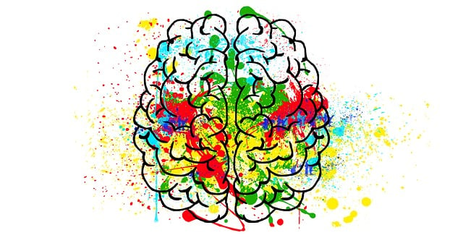

*Psychology: the scientific study of the human mind and behaviour*

*Miss Raj & Ms Kent*

You are required to complete ALL of the activities in this transition pack for the first week of the new academic year. The A Level in Psychology is a fun, embracing yet challenging qualification. It will develop your thinking skills and vastly expand your knowledge of human behaviour.

This is a detailed and comprehensive assignment that you have been given. Do not rush it. We advise that you complete different parts of the transition pack at different points in the Summer holiday, rather than leaving it all until the final week of your break. You should expect to spend longer on these tasks than any homework you have completed before.

**Task One – Approaches in Psychology**

There are six core approaches to Psychology that you need to know for your A level – six different ways of explaining human behaviours. Some of these are listed below: your job is to do some research on them. You should find out: what does this word mean? How might it explain human behaviour? Identify one key researcher from this area – and why are they famous?

The Social Approach

The Behaviourist Approach

The Cognitive Approach

The Biological Approach

Going further extension: The Psychodynamic Approach & Humanist Approach

**Task Two – Psychological History**

You need to create an A3 or A4 Psychological History timeline. On your timeline you should include a number of features such as the ones below (but not necessarily ONLY these). To make a high quality timeline, you will need to do some additional research into what each of the events actually refers to – and why it might have been important to the development of Psychology.

The Curious Case of Phineas Gage, Wilhelm Wundt’s Psychology Lab, foundation of the American Psychological Association, Sigmund Freud publishes “The Interpretation of Dreams”, Pavlov’s Dog Studies are published, Carl Rogers publishes “Counselling and Psychotherapy”, the first use of a brain scan in Psychological research.

This will be a part of one of the topics we will study next year. A great link for this task is <https://allpsych.com/timeline/>.

**Task Three – Psychology Today**

Psychology is still a developing subject, with new research and information being revealed every single day. As keen young Psychologists, you need to keep abreast of new information. Twitter is seen by some to be the future of social science – it is used by researchers, academics and other social scientists alike to share news and information as well as discuss issues:

@SVASocSci (SVA’s Social Sciences feed)

@PsychToday (Psychology Today magazine)

@tutor2uPsych (Tutor2U’s Psychology feed)

@ResearchDigest (the British Psychological Society’s Research feed)

@Psychmag (The Psychologist magazine)

Your second task is to keep an eye on these Twitter accounts (as well as wider sources – the news and shows on TV, newspapers and others – there are loads of fantastic movies and documentaries that you can watch for Psychology!) over the Summer holidays and make a note of any particularly interesting news that is relevant to Psychology.

**Task Four – Drawing Conclusions**

Read the below findings from real-life Psychological studies. You need to draw conclusions from each piece of information by answering the questions in the speech bubbles. Write one short paragraph for each piece of research.

*An experiment found that when people were asked to give a lethal electric shock to another person, they often were willing to do so. When they were asked to do this by a person in ‘ordinary, everyday clothes’, only 20% gave the shock at 450 volts. However, when a man with glasses in a white lab coat asked them to administer the lethal shock, 65% did this. What does this suggest about the power of a uniform?*

*A study into gambling behaviour found that people under 21 years old had less activity in the Pre-Frontal Cortex (an area of the brain) when taking risks than people over 21. How might this be used to explain why young people take more risks, such as drink-driving or speeding, than adults?*

Approximately 1% of the population lives with the disorder Schizophrenia. This means that any ordinary person has a 1% chance of being Schizophrenic. Research has found, however, that if you have a parent with Schizophrenia you are 9% likely to also have it – and if you have an identical twin with it (identical twins share the exact same DNA) you are 48% likely to have it! What does this suggest about whether or not some disorders can be inherited?

A study was conducted in which people were asked to watch a video of a crime and then answer questions about what happened. The people were asked to estimate the size of the knife in the video, ALL participants responded with a length – one even said “a black handle with an eight-inch blade” – but there was no knife in the original video. What does this suggest about whether or not people’s memories can be changed?

It is recommended that by the end of the first week in September you have purchased the Year 1 textbook. There are a number of available textbooks for this course – it is very important that the correct one is purchased. An image has been attached below.

If you have any further questions while you are enjoying your Summer holiday, my email address can be found below 😊

Miss Raj

[araj@highamsparkschool.co.uk](mailto:araj@highamsparkschool.co.uk)