Label the Shapes in French

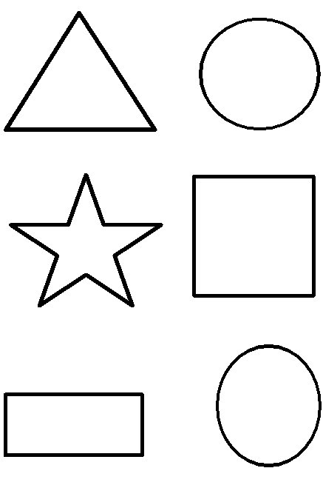

|  |  |  |
| --- | --- | --- |
| le triangle | le rectangle | le carré |
| l’étoile | l’ovale | le cercle |