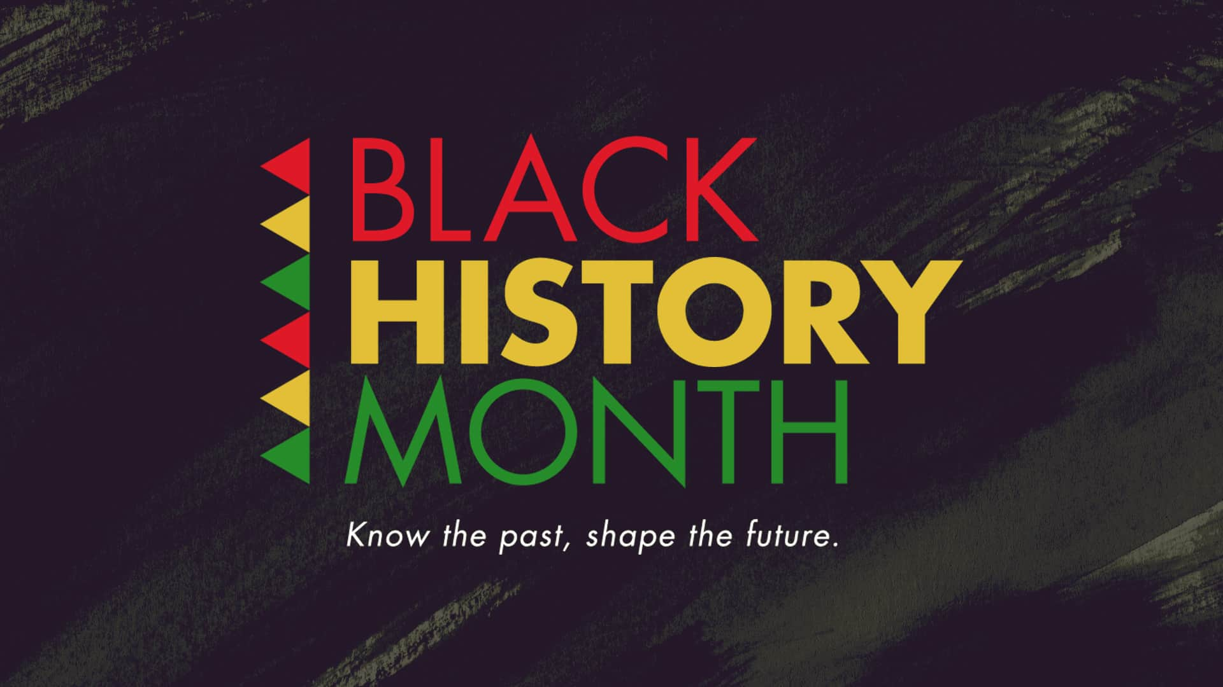

**First Black Librarian**

**Catherine Allen Latimer (1896 – 1948)**

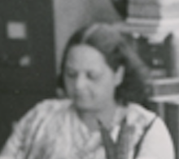

In 1920 Catherine B. Allen Latimer became the first African-American librarian hired by the New York Public Library.  She was one of four black women offered the chance to be hired and was the only one to be chosen.

In 1924 she and [Ernestine Rose](http://nypl-librarians.blogspot.com/search?q=%22ernestine+rose) (Head Librarian at 135th Street) created a reference collection of books on the Negro.

As the first black librarian, she bore the brunt of the prejudice from her white colleagues who opposed the Library’s progress in this area.

Catherine was a devoted cataloguer and reference librarian who over 20 years’ service to the New York Public Library played a major role in the history of the

[**Schomburg Center for Research in Black Culture**](https://www.nypl.org/locations/schomburg)