

**Pourquoi?**

|  |  |  |
| --- | --- | --- |
|  | L’Anglais | Le Français |
| **1** | Because it’s fun |  |
| **2** | Because it’s easy |  |
| **3** | Because it’s difficult |  |
| **4** | Because it’s rubbish |  |
| **5** | Because it’s boring |  |
| **6** | Because it’s creative |  |
| **7** | Because it’s interesting |  |
| **8** | Because the teacher is nice |  |
| **9** | Because the teacher is too strict |  |

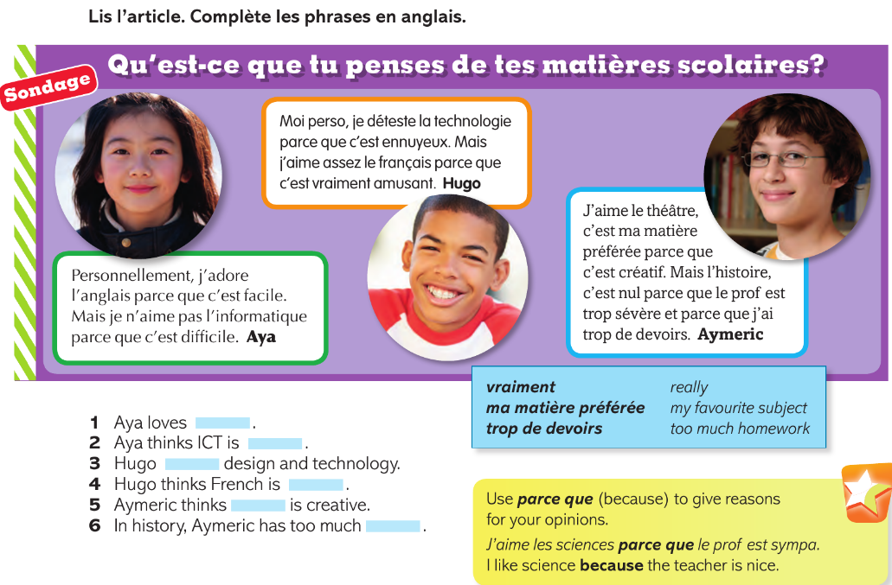

|  |  |  |
| --- | --- | --- |
| Parce que c’est créatif | Parce que c’est ennuyeux | Parce que le/la prof est trop sévère |
| Parce que c’est difficile | Parce que c’est facile | Parce que c’est nul |
| Parce que c’est amusant | Parce que le/la prof est sympa | Parce que c’est intéressant |



**Traduis ces phrases en français.**

**1) I love DT because the teacher is nice.**

**_______________________________________________________**

**2) I hate History because it’s rubbish.**

**_______________________________________________________**

**3) I quite like maths because it’s interesting *but* it’s difficult.**

**_______________________________________________________**

**4) I don’t like geography because it’s boring.**

**_______________________________________________________**

**5) I hate English because the teacher is too strict.**

**_______________________________________________________**

**6) I like Drama because it’s easy and fun.**

**_______________________________________________________**

**7) I don’t like ICT because it’s quite difficult.**

**_______________________________________________________**

**8) I love art as it’s very creative.**

**_______________________________________________________**