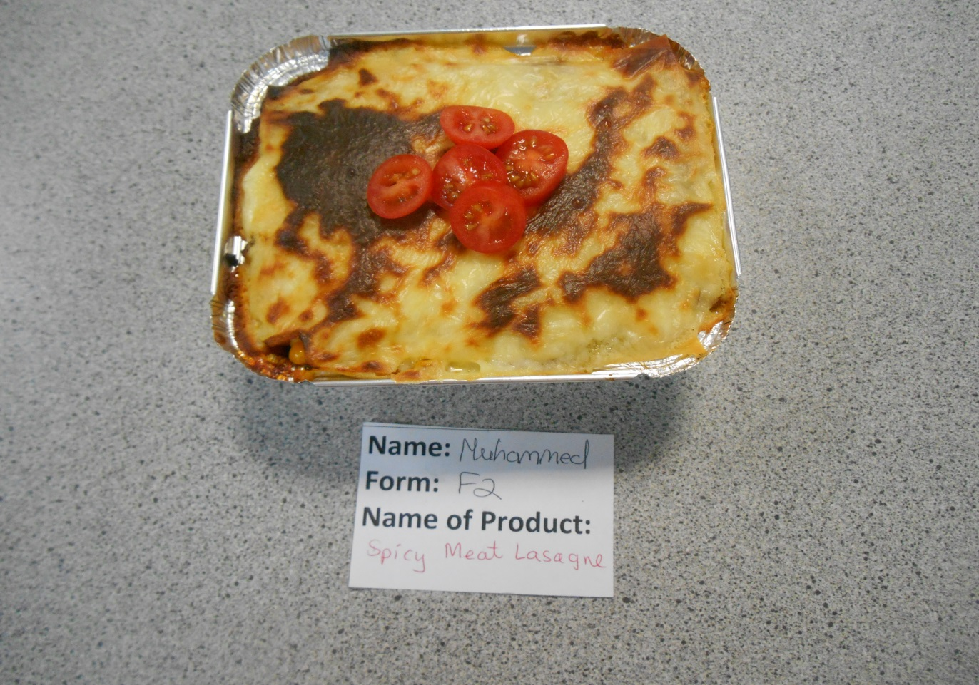**Autumn 2019 Canteen Winners**

Muhammed Ahmed 9F2 made a Spicy Beef Lasagne. It was well layered and had a smooth cheesy sauce and garnished with fresh cherry tomatoes.

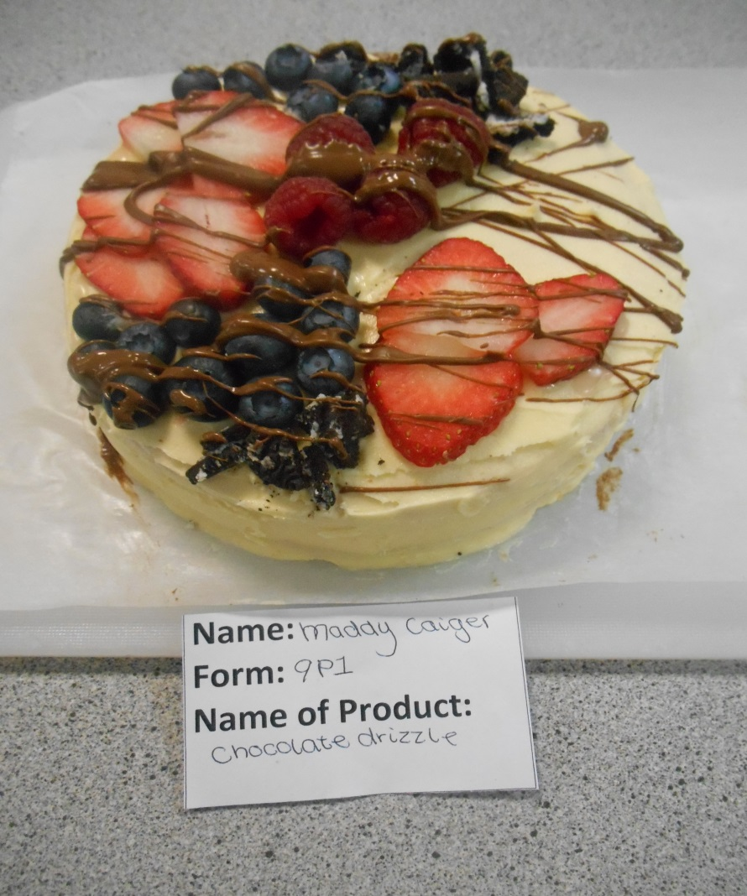

Maddy Caiger Brown 9P1 made a vanilla sponge covered with vanilla buttercream, three berry fruits and a drizzle of milk chocolate so affordable for a canteen and high in fruits for healthiness.