**HPS’s how to make the most of your summer: *Chemistry?***

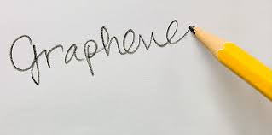**Title:** Is Graphene really a wonder material?

**Aim:** To investigate how a material is taken from discovery to worldwide use.

**Background:** Watch the following videos about Graphene’s discovery.

Graphene on The One Show: <http://bit.ly/Ljl81z>

Graphene: The Next Big (But Thin) Thing: <http://bit.ly/1wu6R1Z>

Read the Following: Graphene Nobel Prize for Physics 2010: <http://bit.ly/1APpfur>

Try and answer the following questions:

* Why does it conduct electricity
* How is its structure related to its strength?
* How is its structure different to that of silicon?
* What are the difficulties of manufacturing Graphene?
* What are the potential applications of Graphene?

**Bring this work with you in September.**

**Course structure:** Edexcel AS/A level Chemistry (8CH0 & 9CH0)

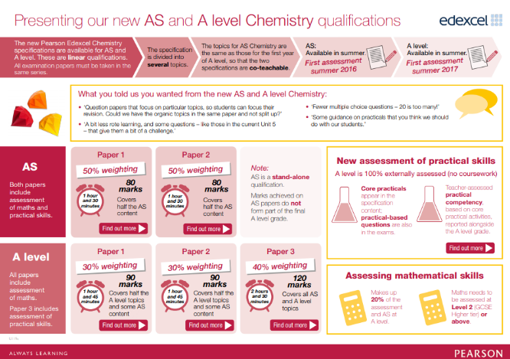

Specification content is arranged into distinct topics and linked to clear descriptive statements, so you know the depth of understanding that’s expected. Topics not only cover physical, organic and inorganic chemistry and fundamental subject elements, but also build on each other to give you a broad knowledge base for assessment, and for progression to further study and the workplace.

**cid:image001.png@01D09F73.E1C95D30This document and more resources are available on Firefly, our Virtual Learning Environment. External students can access a taster of the site via the Highams Park School website. Follow the Firefly link, choose 'Site login (Firefly)' then enter username: hps6thform and password: hps6thform. Current Highams Park students can access all resources using their existing login.**