***Black History Month Suggested Reading for Students:***

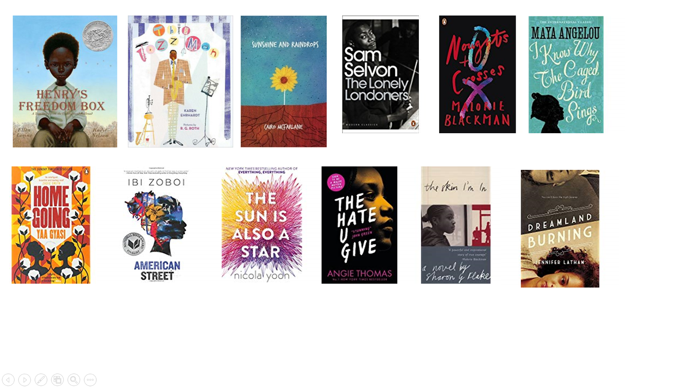

* ***The Sun Is Also A Star* by Nicola Yoon**
* ***The Hate U Give* by Angie Thomas**
* ***Allegedly* by Tiffany D. Jackson**
* ***Another Brooklyn* by Jacqueline Woodson**
* ***Dreamland Burning* by Jennifer Latham**
* ***Piecing Me Together* by Renée Watson**
* ***Everything, Everything* by Nicola Yoon**
* ***American Street* by Ibi Zoboi**
* ***This Side Of Home* by Renée Watson**
* ***The Skin I’m In* by Sharon G. Flake**
* ***Noughts and Crosses* by Malorie Blackman**
* ***Pointe* by Brandy Colbert**
* ***Homegoing* by Yaa Gyasi**
* ***The Lonely Londoners* by Sam Selvon**
* ***Sunshine and Raindrops,* Cairo McFarlane**
* ***The Black Tudors*, Miranda Kauffman**
* ***Black and British,* David Olusoga**
* ***I know Why the Caged Bird Sings,* Maya Angelou**