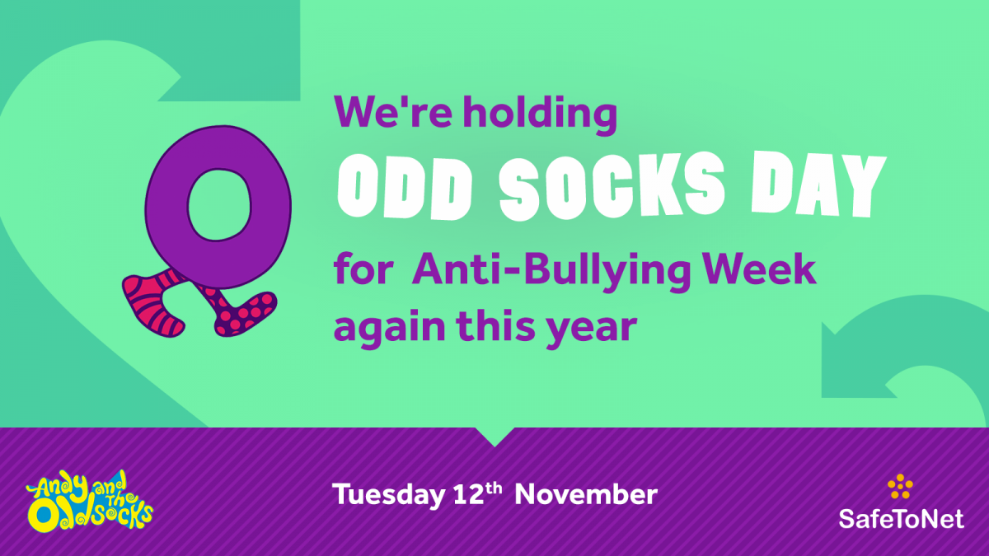****

## What is it?

Most importantly, Odd Socks Day is designed to be fun! It is an opportunity to encourage people to express themselves and celebrate their individuality and what makes us unique!

There is no pressure to wear the latest fashion or for parents to buy expensive costumes.  All you have to do to take part is wear odd socks to your school or workplace, it couldn’t be simpler!  Odd Socks day will take place on the first day of Anti Bullying Week each year **[please note that this year it is happening on Tuesday 12th November 2019 to avoid clashing with Armistice Day]** to help raise awareness of bullying.