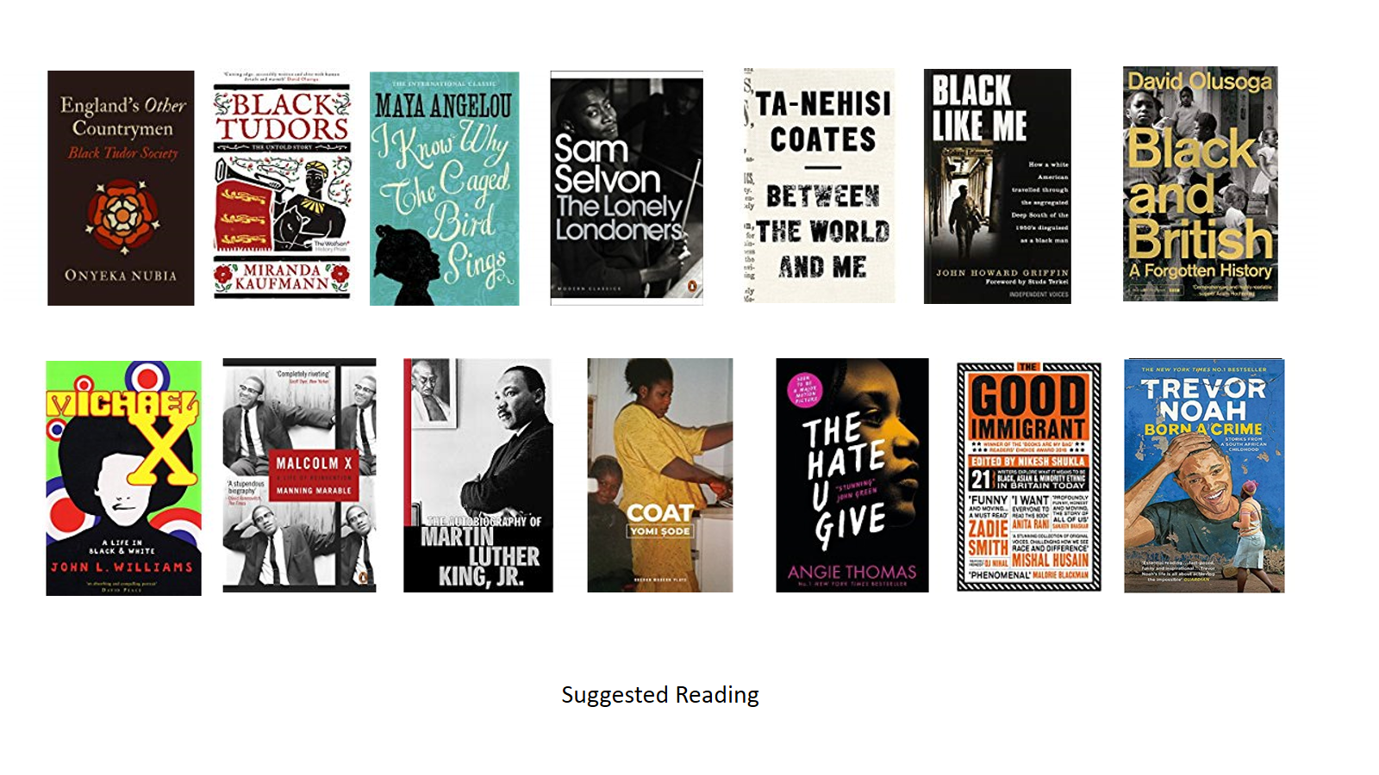

Suggested Reading

* John L Williams, *Michael X*
* Sam Selvon, *The Lonely Londoners*
* Yomi Sode, *Coat*
* Angie Thomas, *The Hate You Give*
* John Howard Griffin, *Black Like Me*
* Ta-Nehisi Coates, *Between the World and Me*
* Maya Angelou, *I Know Why the Caged Bird Sings*
* Martin Luther King Jr, *The Autobiography of Martin Luther King Jr*
* Manning Marable, *Malcolm X: A life of Reinvention*
* Miranda Kaufmann, *Black Tudors: The Untold Story*
* Nikesh Shukla, *The Good Immigrant*
* Onyeka Nubia, *England’s Other Countrymen: Black Tudor Society*
* David Olusoga, *Black and British: A Forgotten History*
* Cairo Macfarlane, *Sunshine and Raindrops*
* Grace Nichols, *I Have Crossed an Ocean*
* Trevor Noah, *Born a Crime*

