**Task 1: Interesting facts and figures**

One of the key components of Core Maths style questions is being able to estimate the answers to questions. To do this accurately you need to have a good knowledge of certain facts or know where to find reliable answers to these questions. Google is a useful starting point, but can we always trust what it says?

For each of the categories below, make a note of your first guess (it doesn’t matter if you have absolutely no idea). Then consult google and write down a better estimate. Finally check a number of sources and write down your final best estimate. We will use these in class discussions next year, so please be honest! It’s not about getting the right answer, it’s about learning new things that you didn’t know before.

|  |  |  |  |
| --- | --- | --- | --- |
| **Question** | **First guess** | **Better estimate (after checking google)** | **Final best estimate (after checking multiple sources)** |
| What is the population of the UK? |  |  |  |
| What is the average UK salary? |  |  |  |
| What is the retirement age in the UK? |  |  |  |
| How many seats on a double decker bus? |  |  |  |
| How many litres of water does a bath hold? |  |  |  |
| What is the distance from Newcastle to Central London? |  |  |  |
| How long does it take to run a marathon? |  |  |  |
| What is the population of the world? |  |  |  |

**Critical Analysis**

**Task 2: Watch the video on** [**misleading statistics**](https://youtu.be/sxYrzzy3cq8) **and answer the questions below:**

|  |
| --- |
| **Which types of bias should we be aware of when analysing statistics?** |
|  |

|  |
| --- |
| **At first, which hospital appears to have the better survival rate?** |
| 🞏 Hospital A 🞏 Hospital B |

|  |
| --- |
| **What type of variable should we be aware of when interpreting statistics?** |
| 🞏 Hospital variable 🞏 Lurking variable  🞏 Sounding variable 🞏 Survival variable |

|  |
| --- |
| **What is the name of the paradox that can turn the results upside down?** |
|  |

|  |
| --- |
| **What was the important factor to consider in the UK study that analyzed smokers and non-smokers?** |
|  |

|  |
| --- |
| **What types of motivation could be at play when people or organizations present statistics?** |
|  |

**Critical Analysis**

**Task 3: Watch the video on** [**how to get statistics to say what we want**](https://www.youtube.com/watch?v=oUs1uvsz0Ok)**, and then read the article on** [**misleading graphs**](https://www.statisticshowto.com/misleading-graphs/)

|  |
| --- |
| **How can numbers or graphs be used to mislead people? Give an example or two.** |
|  |

What is wrong with each of the pictures below? Can you correct the mistake or give a more accurate representation?

|  |  |
| --- | --- |
| **Picture** | **What is wrong or misleading? What could you do to correct it?** |
|  |  |
|  |  |
|  |  |
|  |  |
|  |  |

**Critical Analysis**

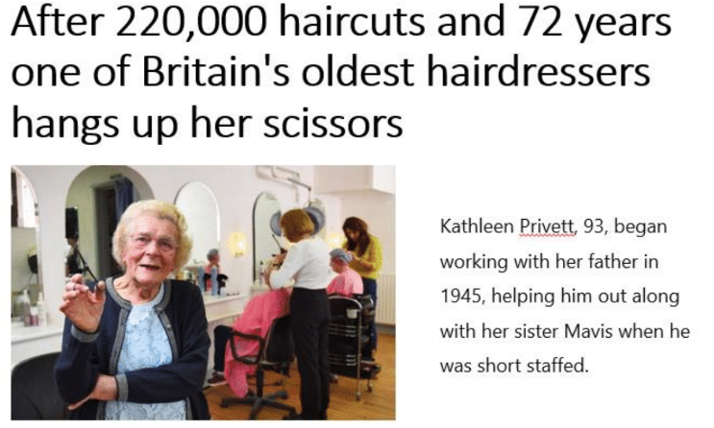**Task 4: Using the question prompts below to help you structure your answer, decide if this headline is reasonable. Could Kathleen have done 220,000 haircuts?**

* What data / information do I need to answer this question?
* Where can I get it from?
* What things do I need to estimate?
* Are my estimates reliable?
* What calculations can I do?
* How can I check that my answer is sensible?
* How can I justify my conclusion?

|  |
| --- |
| **Write up your answer, justifying why you have come to that conclusion. It doesn’t need to be a long essay. Just a paragraph to explain what you did and why you reached your conclusion. Be sure to include any calculations and working out.** |