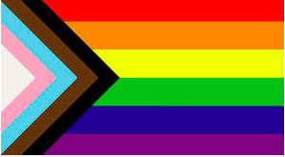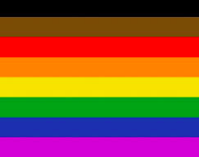

**LGBT+ Key terms**

**LGBT+**- Lesbian, Gay, Bisexual and Transgender, (+) includes any other sexuality along the spectrum and demonstrates inclusivity of all gender identities.

**Ally**- someone who may not identify as LGBT+ but demonstrates a genuine, strong concern for the wellbeing and equality of LGBT+ people

**Queer**- Umbrella term for non-heterosexual identities. When used negatively it is offensive and discriminatory. This term has been popularised in the last decade and is no longer seen as pejorative. For those who may not feel comfortable using this term, it is worth being mindful that some students may use this to refer to LGBT+ identities.

**Gender:**

**Cisgender**: When your gender identity (how you feel) is the same as what doctors/midwives assigned to you when you were born (girl/boy or sex assigned at birth).

**Gender Binary:** A way of seeing gender as two distinct and opposite groups—girl and boy. This idea doesn’t include all the ways we can have a gender identity and express our gender.

**Gender Expansive**: Some people feel that the traditional ways of being a “boy” or “girl” do not fit for them. They live their lives, showing that there are many ways to be a girl, boy, both or neither.

**Gender Expression**: People express themselves in many ways, such as through clothes or hairstyles. Sometimes people think that these things go with certain genders, but really you cannot guess someone’s gender or pronouns from how they look. In our school we respect that every person is unique and different, and we don’t tease or bully anyone about their personal expression.

**Gender Identity**: How you feel. Girl, boy, both or neither. Everyone has a gender identity.

**Intersex:** An umbrella term that refers to people who are born with bodies that are naturally different from what is traditionally considered female or male. (This occurs in about 2% of babies born)

**Non-Binary**: People who do not feel like the word's “girl” or “boy” fits. They may feel like both or neither. They sometimes use pronouns such as they, them, theirs.

**Sex Assigned At Birth:** When a baby is born, a doctor or midwife looks at the baby’s body/anatomy and says they are a boy, girl or intersex.

**Transgender** or **Trans**: When your gender identity (how you feel) is different than what doctors/midwives assigned to you when you were born (girl/boy or sex assigned at birth).

**Who you love:**

**Bisexual**: People who love people of more than one gender.

**Gay**: People who love people of the same gender.

**Heterosexual:** People who identify as women who only love [or are attracted to] people who identify as men. Also, people who identify as men who only love [or are attracted to] people who identify as women.

**Lesbian**: People who love people of the same gender. Two women.

**Pansexual**: People who love people of any gender.

**Sexual Orientation:** Who you fall in love with.

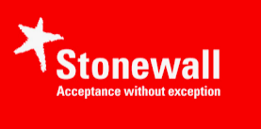

**Stonewall also has a glossary (and excellent educational resources and advice) which includes some additional terms that you may wish to familiarise yourself with:** [**https://www.stonewall.org.uk/help-advice/faqs-and-glossary/glossary-terms**](https://www.stonewall.org.uk/help-advice/faqs-and-glossary/glossary-terms)