A damning parliamentary report on racism makes it clear: the system isn't working

[*Nasar Meer*](https://www.theguardian.com/profile/nasarmeer)

This article is more than 10 months old

The human rights committee has pointed out that we don’t need more inquiries into racial equality – we need to act

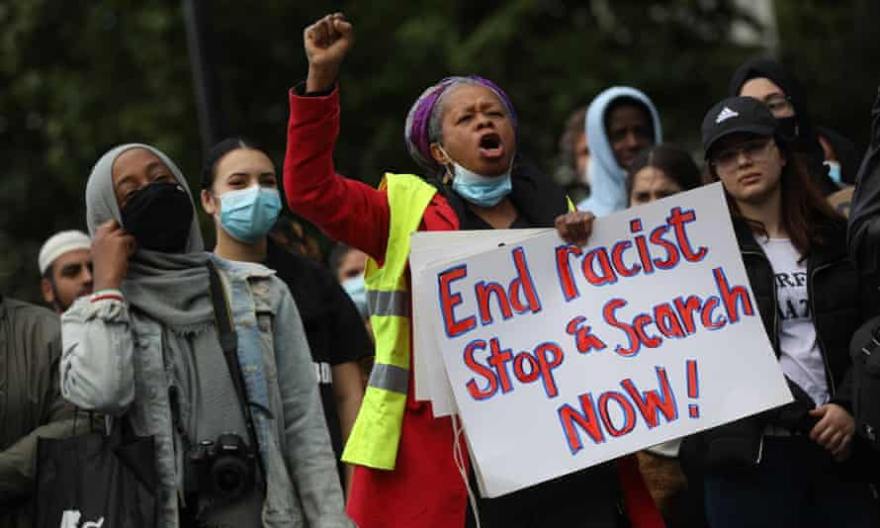

‘Black children are four times more likely to be arrested than their white counterparts.’ A Black Lives Matter protester makes a point about stop and search, London, June 2020. Photograph: Isabel Infantes/EMPICS Entertainment

Thu 12 Nov 2020 15.44 GMT

There is a tendency to think racism in our societies will lessen over time, and that attitudes and outcomes will inevitably improve. This belief endures despite frequent and sobering evidence of deeply entrenched racial inequalities in Britain.

One of the key points found in Black People, Racism and Human Rights, [a new report](https://committees.parliament.uk/publications/3376/documents/32359/default/) from the House of Commons and House of Lords joint committee on human rights, is not only that racial progress is far from advancing, but that some things are getting worse.

Take the finding that “in the last decade, the extent to which black children and young people are disproportionately targeted by the youth justice system has increased”.

Advertisement

This claim is easily demonstrated by consulting [youth justice statistics](https://assets.publishing.service.gov.uk/government/uploads/system/uploads/attachment_data/file/862078/youth-justice-statistics-bulletin-march-2019.pdf) for 2018/2019 in England and Wales, which show that black children (who make up about 4% of the entire population aged between 10–17 years) are four times more likely to be arrested than their white counterparts, and nearly three times more likely to receive a caution or custodial sentence. Today the percentage of black children in custody has significantly increased to 28% of the entire population held in youth custody (compared with 15% a decade ago).

This is one among very many racially disproportionate outcomes that have worsened in real time despite at least eight other parliamentary publications since 2009, each of which made good recommendations for addressing racial inequalities in Britain. Add to these a litany of other inquiries in recent years, including the [Windrush Lessons Learned](https://www.theguardian.com/uk-news/2020/mar/19/windrush-review-to-call-for-reform-of-reckless-home-office) review (2020), the [race disparity audit](https://www.theguardian.com/commentisfree/2017/oct/10/theresa-may-race-audit-guardian-panel) (2017, spanning nearly all public sectors), the [Lammy report](https://www.theguardian.com/law/2017/sep/08/racial-bias-uk-criminal-justice-david-lammy) (2017, looking specifically at criminal justice), the [McGregor-Smith review](https://www.theguardian.com/money/2017/feb/28/bme-career-progression-could-add-24bn-a-year-to-uk-economy) (2017, focusing on labour markets) and the [Angiolini review](https://www.theguardian.com/uk-news/2017/sep/04/families-of-people-who-died-in-police-custody-failed-by-system-report) (2017, investigating deaths in police custody). What each of these reports makes plain is that in order to deny that racism is a key feature of disparities in these sectors, institutions and organisations must actively try to ignore it.

Perhaps this is why Baroness Lawrence asked the joint committee, “How many more lessons do we all need to learn? The lessons are there already for us to implement.” Indeed, it will soon be 30 years since the racist murder of teenager Stephen Lawrence, an event that lead, after six years of campaigning, to a public inquiry that deemed the UK’s largest police authority to be guilty of [institutional racism](https://www.theguardian.com/uk-news/2019/feb/22/institutional-racism-britain-stephen-lawrence-inquiry-20-years).

Last year marked 20 years since the [Macpherson report](https://www.theguardian.com/uk-news/2019/feb/22/macpherson-report-what-was-it-and-what-impact-did-it-have) into Lawrence’s death was published and then, much as now, a key issue is the role of what is deemed “unwitting”. This is precisely how institutional racism came to be described in the inquiry into the Metropolitan Police. The report’s wide-ranging recommendations had a broad scope that translated into the 2003 Race Relations Amendment Act, and so had implications across the public sector and society more broadly.

Yet while legislating against discrimination is key, two other things matter just as much.

The first is social convention, to the extent that legislating against individual motives and objectives does not explain how racial inequalities sustain and proliferate. Take the well-established but still shocking fact, highlighted in the joint committee report, that while the rate of deaths of women in childbirth have fallen for white women (to 7 in 100,000), it has increased for black women (to 38 in 100,000). The obstetrician and gynaecologist Dr Christine Ekechi, sums up the description of possible unwitting reasons, when she says that, “People think of racism in an overt, aggressive way. But that’s not always what it is. It’s about biased assumptions – and we doctors have the same biases as anyone else.” This might include prejudiced attitudes among healthcare workers about black patients having higher pain thresholds, being too demanding, or not understanding their treatment – all of which manifests in not being listened to.

As the racial disproportionality [highlighted by the Covid-19 pandemic](https://www.theguardian.com/world/2020/apr/22/racial-inequality-in-britain-found-a-risk-factor-for-covid-19) makes plain, and as documented in the joint committee report too, though racial inequalities in health are driven by social and economic factors, harmful (and flawed) assumptions about “culture” are pervasive, and deflect responsibility on to the victims of structural discrimination.

The second issue is enforcement. It is notable that the joint committee specifically states that “the Equality and Human Rights Commission (EHRC) has been unable to adequately provide leadership and gain trust in tackling racial inequality in the protection and promotion of human rights”. It is an observation that confirms a widely held view among community groups. That an amalgamated equality body risked both diluting and de-prioritising race equality was a frequently aired concern when the EHRC was first created in 2007, by bringing all the other equality “grounds” together (race, gender, disability) before assuming responsibility for newer ones (age, sexual orientation, and religion or belief) in anticipation of the [Equality Act 2010](https://www.theguardian.com/careers/careers-blog/a-guide-to-the-new-equality-act).

That these precise concerns have come to pass surprises nobody outside of an organisation that few race-equality stakeholders feel connected to, something typified by its nearly all-white board of commissioners. That it has not one black commissioner is a disgrace, and itself evidence of a profound institutional failure on race equality.

The truth is that we do not need any more reports to tell us that racial equality in Britain is in a pitiful state. What we do need is action to drive policy, implementing the myriad of good recommendations that we already have. We also need to recognise that success in race equality is going to be about more than public policy, because to tackle what is “unwitting” requires us to reflect on the character of society: asking who and what we think we are, and want to be. Achieving that task, I fear, is a long way off.

 Nasar Meer is a professor of race, identity and citizenship at the University of Edinburgh

# **Institutional racism doesn’t exist,’ government’s race commission suggests in landmark report**

## **Commission says ‘overt and outright racism persist’ but says UK should be example to other ‘white majority’ countries**

[**Nadine White**](https://www.independent.co.uk/author/nadine-white)**,**[**Ashley Cowburn**](https://www.independent.co.uk/author/ashley-cowburn)

Wednesday 31 March 2021 00:

The government’s highly anticipated race report commissioned in the wake of the [Black Lives Matter](https://www.independent.co.uk/topic/black-lives-matter) protests has rejected suggestions that Britain is still an institutionally racist country.

The 264-page report concludes that the UK has become a “more open society” where children from many ethnic communities perform as well or substantially better than white pupils in compulsory education.

The independent review – which is published on Wednesday – argues that issues around race and [racism](https://www.independent.co.uk/topic/racism) are “becoming less important” and, in some cases, are not a significant factor behind explaining disparities.

[**Race report news - live: Government investigation branded ‘an insult’**](https://www.independent.co.uk/news/uk/politics/race-report-racism-sewell-latest-b1824936.html)

However, race advisers have warned that Britain is not “a post-racial society” and that “overt and outright racism persists in the UK”, particularly online.

Ahead of the report’s release, a government summary states: “The landmark report challenges the view that Britain has failed to make progress in tackling racial inequality, suggesting the well-meaning ‘idealism’ of many young people who claim the country is still institutionally racist is not borne out by the evidence.”

It comes after numerous reports published last year cited evidence of structural inequalities including the Public Health England (PHE) review of disparities in the risk and outcomes of Covid (2020), the Lawrence Review (2020), and Windrush Lessons Learned Review (2020).

The PHE probe found that: “Given the limitations of the PHE review, work was especially called for on the socio-economic, occupational, cultural and structural factors (racism, discrimination, stigma) influencing Covid-19 outcomes in Bame communities within and outside the health sector.”

While the Lawrence Review, commissioned by the Labour Party and led by Baroness Doreen Lawrence, concluded that “decades of structural discrimination led to the disproportionate impact of the pandemic on minority ethnic communities”.

In the Lessons Learned Review Wendy Williams, Her Majesty’s Inspectorate of Constabulary and Fire & Rescue Services, noted that “these failings demonstrate an institutional ignorance and thoughtlessness towards the issue of race and the history of the Windrush generation within the department, which are consistent with some elements of the definition of institutional racism”.

### **Most watched**

Following her Race Disparity Audit in 2017 which revealed the widespread impact of discrimination in the UK, former prime minister Theresa May said the data “will provide the definitive evidence of how far we must still go in order to truly build a country that works for everyone”.

Tony Sewell, chairman of the Commission on Race and Ethnic Disparities, who has previously made comments denying the existence of institutional racism, said: “The report highlights the significance of education as the single most powerful tool in reducing ethnic disparities.

“The effect of education is transformative on individuals but also their families and their communities, sometimes within a generation.

“Another revelation from our dive into the data was just how stuck some groups from the white majority are. As a result, we came to the view that recommendations should, wherever possible, be designed to remove obstacles for everyone, rather than specific groups.”

The former education charity boss and one-time colleague of Boris Johnson, added: “Creating a successful multi-ethnic society is hard, and racial disparities exist wherever such a society is being forged.” But, he added, the country should be an example to other “white majority countries”.

“The commission believes that if these recommendations are implemented, it will give a further burst of momentum to the story of our country’s progress to a successful multi-ethnic and multicultural community – a beacon to the rest of Europe and the world.”



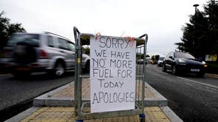

In 2019 Black African pupils performed above their white British counterparts on average in GCSE exams, while Black Caribbean pupils were the only ethnic group who performed lower than white British pupils, new research commissioned by the group found.

The commission has suggested that some communities continue to be “haunted” by “historic cases” of racism, creating “deep mistrust” in the system which prevent them from being successful.

The report makes 24 recommendations including the commissioning of further research into the drivers in “high performing pupil’s communities” to see what can be replicated to support all children to succeed.

Last summer, Boris Johnson announced the cross-government inquiry into “all aspects” of racial inequality in Britain in response to the Black Lives Matter protests that swept across the globe, highlighting endemic racism and widespread injustices”.

“We have to acknowledge that when thousands of people march peacefully for Black Lives Matter, you can’t ignore that,” the prime minister said at the time. “I, as a leader, as someone in government, I can’t ignore the strength of feeling.”

But in a scathing attack at inaction from successive governments, [David Lammy](https://www.independent.co.uk/topic/david-lammy) claimed the promise to hold a commission – first announced in a comment piece for *The Daily Telegraph* – was “written on the back of a fag packet to assuage the Black Lives Matter protesters”. Speaking in June, the shadow justice secretary demanded: “Get on with the action, legislate, move. You’re in government – do something.”

Referencing a previous report he led in 2017 into racial disparities in the criminal justice system, the Labour frontbencher said: “I made 35 specific limit recommendations in the Lammy review. Implement them.

“There are 110 recommendations in the Angiolini review into deaths into police custody. Implement them. There are 30 recommendations in the Home Office review into the Windrush scandal. Implement them. There are 26 in Baroness McGregor-Smith’s review into workplace discrimination. Implement them.”