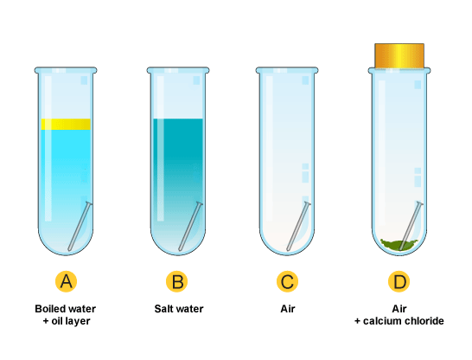

Tube C

Tube B

Tube D

Tube A

Record your observations

Tube A. Iron and _______

Tube B. Iron, water, ________ and salt

Tube C. Iron, oxygen and ________

Tube D. Iron and _________

Conclusion

Investigating rusting



Tube C

Tube B

Tube D

Tube A

Record your observations

Tube A. Iron and _______

Tube B. Iron, water, ________ and salt

Tube C. Iron, oxygen and ________

Tube D. Iron and _________

Conclusion

Investigating rusting