**BTEC Level 3 National Diploma in Business – Transition Work**

**As part of the BTEC Level 3 Diploma course, you will be expected to complete 4 units in each year totalling as 8 units over two years.**

**In year 12, you will learn about:**

* Understanding the Nature and the Purpose of Businesses
* Understand how to Develop a Marketing Campaign
* Understand Business and Personal Finance

**What can I do this summer?**

**Business Ownership**

1. **Research** two different *business organisations* of your choosing, you may choose to use the internet, newspaper articles, videos or books to accompany your research
2. **Write** a report about your *chosen business organisations.* The report can take *any format* you feel is appropriate. You can write it as an essay, newspaper article, presentation, video etc.

**Highlands Fish Bar (Sole trader)**

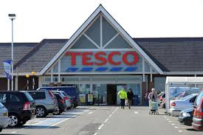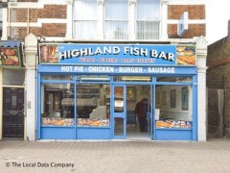

**Tesco (Public Limited Company)**

**Success Criteria:**

**Make sure you include all of the following areas in your report:**

1. **From your research, select:**

* One large Public Limited Company (PLC) or Private Limited Company (LTD) and
* One small business organisation i.e. with less than 10 staff. This could include a sole trader, partnership or a not for profit organisation.

1. **Describe the following elements for each of your selected organisations:**

* Type of organisation (including size, sector and ownership)
* Define limited liability and unlimited liability and describe their impact on your business
* Purpose of organisation (including its main products and services, distinguishing features of the organisation and aims)

**This document and more resources are available on Firefly, our Virtual Learning Environment. External students can access a taster of the site via the Higham’s Park School website. Follow the Firefly link, choose 'Site login (Firefly)' then enter username: hps6thform and password: hps6thform.**

**Current Higham’s Park students can access all resources using their existing login.**