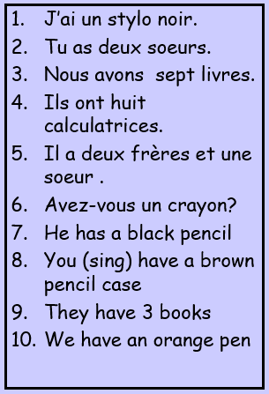

1. ____________
2. ____________
3. ____________
4. ____________
5. ____________
6. ____________
7. ____________
8. ____________
9. ____________
10. ________________