[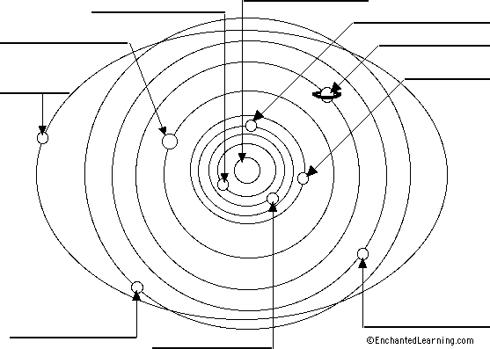](http://www.enchantedlearning.com/label/)

[](http://www.enchantedlearning.com/label/)