**Summer 2019 Canteen Winners**

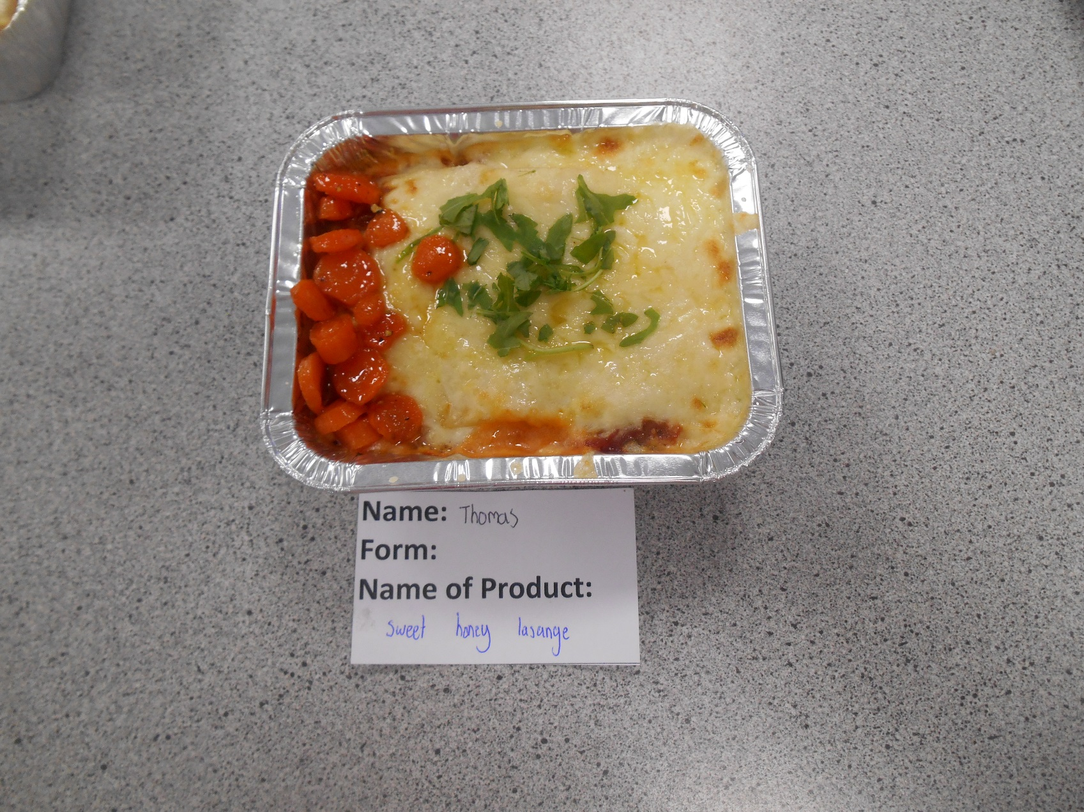

Thomas Laing 9F2 made a Sweet Honey Beef Lasagne. It was well layered and had a smooth cheesy sauce and garnished with fresh herbs and honeyed carrots.

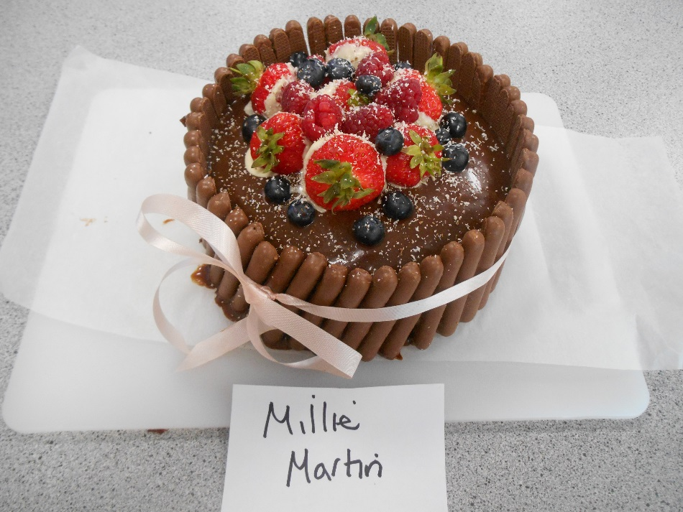

Millie Martin 9B2 made a light sponge covered with a chocolate ganache, raspberries, blueberries, strawberries and a shaving white chocolate and finished with chocolate finger edging. It was high in fruits for healthier canteen dessert.