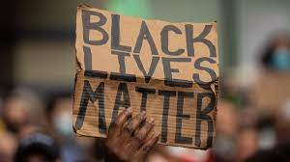**Institutional Racism in Business Industries**

1. **What is Institutional Racism?**

Institutional racism is discrimination or unequal treatment on the basis of membership of a particular ethnic group, arising from systems, structures, or expectations that have become established within an institution or organization.

1. **What is the ethnic pay gap?**

Ethnic pay gap reports show the difference between the average, mean and median earnings of businesses’ BAME (Black, Asian and minority ethnic) employees and non-BAME members of staff. The Office for National Statistics (ONS) reports for the ethnicity pay gap each year. The most recent publication from the ONS on the ethnicity pay gap found that:

* The pay gap between white and ethnic minority employees has narrowed to its smallest level since 2012 in England and Wales.
* Most of the minority groups analysed continue to earn less than white British employees but, in 2019, those in the Chinese, White Irish, White and Asian, and Indian ethnic groups earned higher hourly pay than white British employees.
* The ethnicity pay gap is larger for men than women.
* The ethnicity pay gap for those aged 30 and over is larger than for those aged 16 to 29 years.
* The ethnicity pay gap differs across regions and is largest in London.) reports on the ethnicity pay gap each year.

1. **How did Multinational corporations respond to this and why was it accused of being stereotypical?**

Not too long ago, few companies paid much attention to Black Lives Matter. Today, in the wake of the George Floyd protests, it seems as if most major companies including Apple, Amazon and Facebook have endorsed the movement – or at a minimum pledged millions of dollars to fight racism and vowed to do more to end discrimination in their workplaces.

Businesses have been increasingly embracing what is known as brand activism, taking a stand on social, environmental, or political issues. It’s a trend driven by consumer behaviour, as more and more people expect companies to make a positive contribution to society.

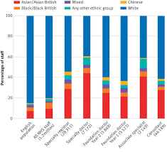

By, Hassan, Elijah, George and Giuseppe