**A Level Maths Transition Work 2023**

**Task 1:**

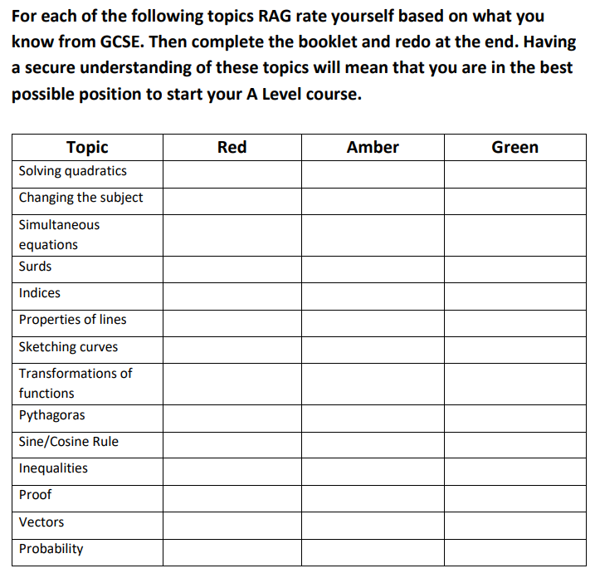

**Task 2:**

**Basic Skills Check**

Complete the following booklet. Once you have completed all the questions, use the answer booklet to mark/correct your work in green pen.

In this booklet, there are a range of questions from key topics that you will have seen in GCSE and will be helpful for AS Level and A-Level.

Each topic has three sections:

* Introduce questions allow you to practise the key concepts.
* Strengthen questions build on your knowledge of the key concepts.
* Deepen questions will challenge your understanding

[Sparx Transition booklet](https://cdn.document360.io/2bee100a-a9af-4313-a064-74c31f5b0420/Images/Documentation/Sparx%20Maths%20-%20GCSE%20to%20A-Level%20Transition.pdf)

[Sparx Transition booklet answers](https://cdn.document360.io/2bee100a-a9af-4313-a064-74c31f5b0420/Images/Documentation/Sparx-Maths_GCSE-to-A-Level-Answers.pdf)

**Task 3:**

**Extra Practice**

1.Exam style practice. For each of the topics you should watch the video, and then answer the exam questions and mark your answers. Where have you made mistakes? Is there something you need to do more work on?

Algebraic fractions

<http://www.mathsgenie.co.uk/algebraic-fractions.html>

<http://www.mathsgenie.co.uk/resources/algebraic-fractions.pdf>

Forming equations

<http://www.mathsgenie.co.uk/forming-and-solving-equations.html>

2. Complete the A Level transition questions. <https://gryphonmaths.wordpress.com/a-level/transition/task-1/>

3. Watch the video and then complete the tasks at the end. <https://library.leeds.ac.uk/skills-algebra>

4. Underground Mathematics This resource is FULL of lots of tasks and challenges. If you are feeling less confident with a topic then use the ‘building block’. If you want more of a challenge then carry out one of the ‘fluency exercise’. <https://undergroundmathematics.org/>

**Task 4:**

**Exciting and Interesting Bits**

Below are some articles and videos to view. These are all going to extend your understanding of maths in the real world.

1. Follow the ‘WATCH, THINK, DIG DEEPER, DISCUSS’ The Wizard standoff riddle. <https://ed.ted.com/lessons/can-you-solve-the-wizard-standoff-riddle-daniel-finkel>

2. Follow the ‘WATCH, THINK, DIG DEEPER, DISCUSS’ Solve the false positive riddle. <https://ed.ted.com/lessons/can-you-solve-the-false-positive-riddle-alex-gendler>

3. Read the notes on the page and carry out the algebraic investigation. Complete the worksheet included. <https://www.teachmathematics.net/page/7566/oxo>

4. Create a PINTREST board with images of maths in nature. Investigate the maths behind some of the images you have found.

5. Maths Magic. Can you create your own version of the problem? Investigate other magic tricks which are based around maths. <https://nrich.maths.org/1051>