Bonjour!! Au revoir!!

Comment tu t’appelles? *What are you called?*

Je m’appelle……………………. *I am called……………………..*

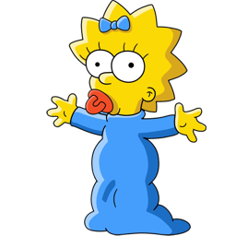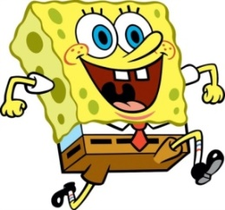

Comment il s’appelle? Comment elle s’appelle?

Il s’appelle Sponge Bob. Elle s’appelle Maggie.

*What is he called?*  *What is she called?*

*He is called Sponge Bob.* *She is called Maggie.*

***La Question******La réponse***

|  |  |  |
| --- | --- | --- |
| 1. Comment il s’appelle? | http://vignette2.wikia.nocookie.net/spongebob/images/2/2f/Patrick_Star_2.png/revision/latest?cb=20150117190123 | 1. |
| 1. Comment elle s’appelle? | http://cdn.imgs.tuts.dragoart.com/how-to-draw-tinkerbell_1_000000000143_5.jpg | 2. |
| 1. Comment il s’appelle? | http://cdn.playbuzz.com/cdn/e3fdd71d-195b-401f-9f02-c68e427f77a6/8bacbf91-f256-443a-830d-8c7f4078cad0.jpg | 3. |
| 1. Comment elle s’appelle? | http://cdn01.cdn.justjaredjr.com/wp-content/uploads/headlines/2014/08/taylor-swift-cheer-outtakes.jpg | 4. |
| 1. Comment il s’appelle? | http://img.bleacherreport.net/img/images/photos/002/697/193/461418693_crop_north.jpg?w=630&h=420&q=75 | 5. |
| 1. Comment tu t’appelles? | http://www.midlandphotoboothrental.com/wp-content/uploads/2012/11/Empty-frame.jpg | 6. |