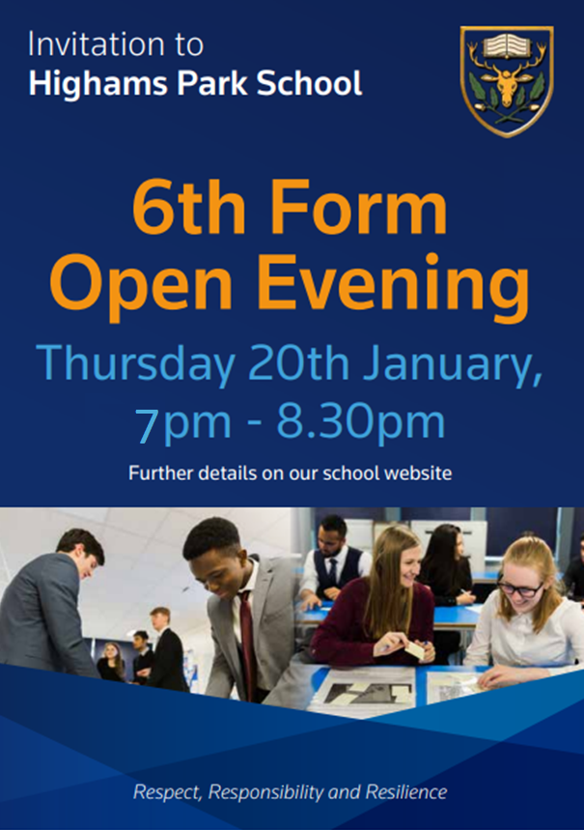 External applicants can book for the open evening [here](https://outlook.office365.com/owa/calendar/highamsparkschool@highamsparkschool.co.uk/bookings/) or via our school website.

External Applicants