- a What do most scientists think is causing the rise in global temperatures?
b What effects could this temperature rise have?
- a What is meant by the ‘greenhouse effect’?
b Would we be better off on Earth without the greenhouse effect? Explain your answer.
- List two main causes of the rising concentration of carbon dioxide in the atmosphere?
- Look at the graphs below. Graph A shows the changes in carbon dioxide concentration over the last 1000 years in parts per million (ppm). Graph B shows the mean temperature of each year compared to the mean temperature for the years 1961–1990 (this is set at 0 on the graph). The dashed line shows the predicted increase in temperature from 2000.
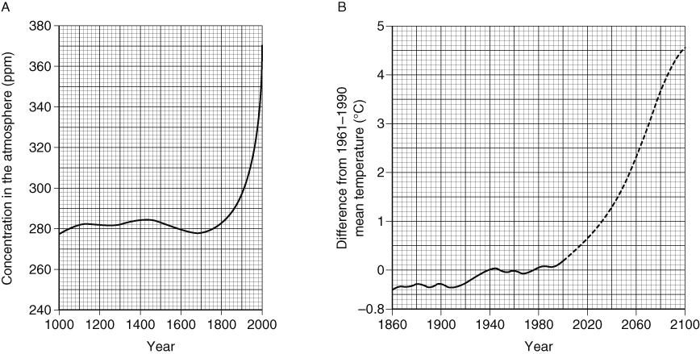
- What was the carbon dioxide concentration (approximately) between 1000 and 1800?
- In 1900, how much lower was the mean temperature than it was in 1961–1990?
- In which year did temperature levels start to rise above the mean value for 1961–1990?
- Describe the current trend in carbon dioxide concentration.
- What has been the general trend in mean world temperature over the last 100 years?
- What does the graph predict will happen to mean temperature over the next 100 years?
- Using the graphs, describe any link between the mean world temperature and the carbon dioxide level.
- Do you think these graphs provide good evidence that rising temperatures are caused by rising concentration of carbon dioxide? Explain your answer.
- Scientists use computer models to predict how rising temperatures could affect the future climate of the Earth.
- What information do you think they need to put into such computer models?
- Suggest why different computer models give different predictions about future climates.
I can…
- recall the causes and effects of global warming
- interpret information from graphs.

