Name Class Date
The drawing below shows some sources of carbon dioxide from human activities.
- Label the drawing to show which human activities produce carbon dioxide, and why they produce carbon dioxide.
- For each label, add notes to explain how the amount of carbon dioxide produced by that activity could be reduced. Try to think of more than one way of reducing emissions from each source.
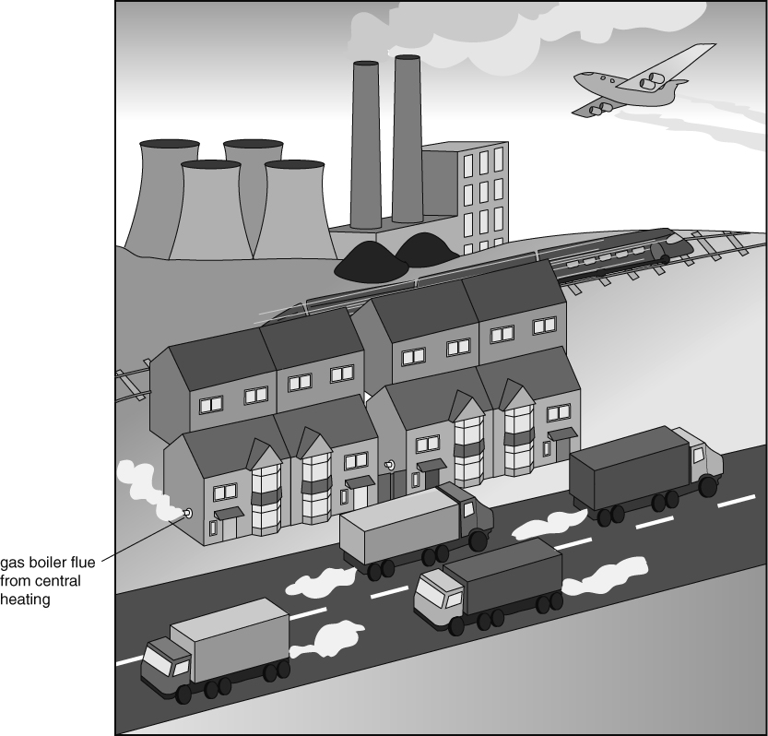
I can…
- explain how carbon dioxide emissions from human activity can be controlled.

