Predicting the effect of increasing carbon dioxide and other greenhouse gases in the atmosphere is very difficult. We understand how greenhouse gases in the atmosphere affect how much of the energy emitted from the warm Earth’s surface escapes into space and how much is returned to the surface. However, there are many factors that can affect how much of the Sun’s energy reaches the ground, how much is absorbed by the Earth and how much escapes into space.
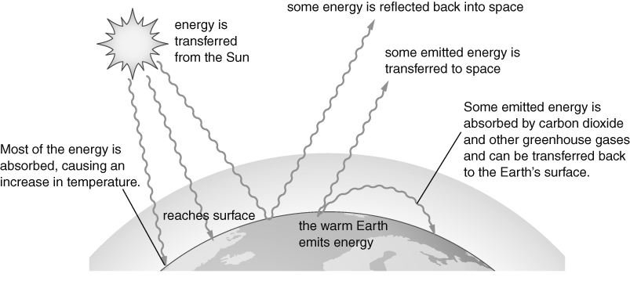
One factor is the amount and type of cloud. Clouds block some of the Sun’s energy from reaching the Earth’s surface and reflect it away from Earth and back into space. However, energy that is emitted from the Earth’s surface may be reflected by clouds back to the surface, preventing it from escaping to space. This will cause the Earth’s surface to get warmer.
Another factor is the colour of the Earth’s surface. Lighter colours reflect more energy, while darker colours absorb more energy. This is particularly important in relation to ice. Large areas of ice, such as ice caps, reflect more light than the rock around them. However, the energy the ice absorbs will cause melting. As the ice melts, more dark rock is exposed and more energy is absorbed rather than reflected, so more ice melts, and so on. This is an example of positive feedback, where a change makes more change more likely. Predicting this feedback effect depends on understanding how ice melts in different situations.
To help predict the future effects of global warming, scientists use computer models that include all the factors that they know have an effect on the absorption and emission of energy from the Earth’s surface. These models are huge and complicated. As a result, small changes in a factor can produce large differences in predicted change. So the modelling program must be run millions of times, with slight differences in values for factors each time, to see what happens. If many of the test runs produce a similar result, scientists can be more confident about their predictions using the model.
In 2013, a project organised by Oxford University via the BBC used thousands of volunteers to run their climate prediction program. The results of the project predicted a rise in between 2 and 4 °C in temperature in the UK by 2080. It also predicted warmer, wetter winters and hotter, drier summers.
Read through the information text above, and then use it to answer these questions.
- Write a title for this text to sum up what it is all about.
- For each paragraph, write a sentence that describes the key point in that paragraph. Use no more than 8 words in each sentence.
- Use your answers to Question 2 to draw a concept map that links all the key points in the text.
I can…
- use information and explanation text to answer questions clearly.

