- a Sometimes two variables are linked. Look at graph A and describe the link between changes in temperature and changes in the amount of carbon dioxide in the air.
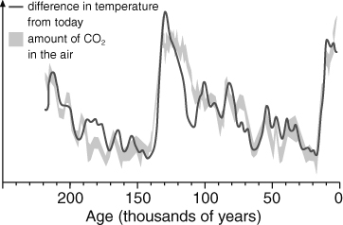 | A The mean (average) Earth surface temperature and carbon dioxide concentration in the air over the past 250 000 years.
b One interpretation of graph A is that carbon dioxide causes warming. Explain how this is thought to happen.
c A link between two variables does not necessarily mean that a change in one causes a change in the other. Suggest one other possible interpretation of graph A.
Evidence from temperature measurements clearly shows that global warming is happening now. Many people use the patterns in graph A to say that emissions of carbon dioxide from human activities are causing the global warming. Others disagree and say that human activity is not the cause of global warming. Some statements are better supported by evidence than others.
- a Match up the boxes below to form pairs covering the same point. One box argues in favour of human activity causing global warming and the other argues against.  b For each pair, decide which box contains the ‘stronger’ statement. Give a reason for each decision.  c Look at poster advert B. It was produced by a group that does not think human activity has caused global warming. Design your own poster that has the opposite message. | 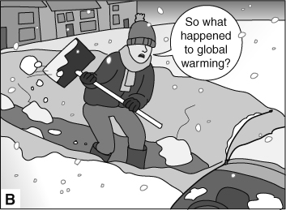

More than 31 000 scientists don’t think that human activity is causing global warming. |  | A number of different studies of different aspects of climate, covering different times in Earth’s past, all lead to a conclusion that a doubling of carbon dioxide in the air will raise the temperature by about 3 °C.
The Sun could be causing global warming because when there are more sunspots, the Sun is more active and the Earth gets warmer. |  | The link between solar activity and Earth temperature is sometimes, but not always, true. At the moment, though solar activity is quite low, warming is still increasing.
Fossils and rocks show that there have been warmer times in the past even when carbon dioxide concentration was lower than now. So current changes could be natural. |  | Computer models do show that small changes can make big differences. But many different models, run thousands of times, all suggest that the amount of carbon dioxide released by human activity is causing a warming effect.
Computer models are not complicated enough to get it right, and tiny changes can make great differences. Therefore, we can’t be sure that the models are right. |  | Over 97% of published papers on global warming agree that human activity is the cause.
I can…
- evaluate evidence for and against the idea that human activity is causing global warming.

