

Name Class Date
- The diagram explains how the greenhouse effect works. Cut out the labels at the bottom of the sheet and stick them onto the correct places on the diagram.
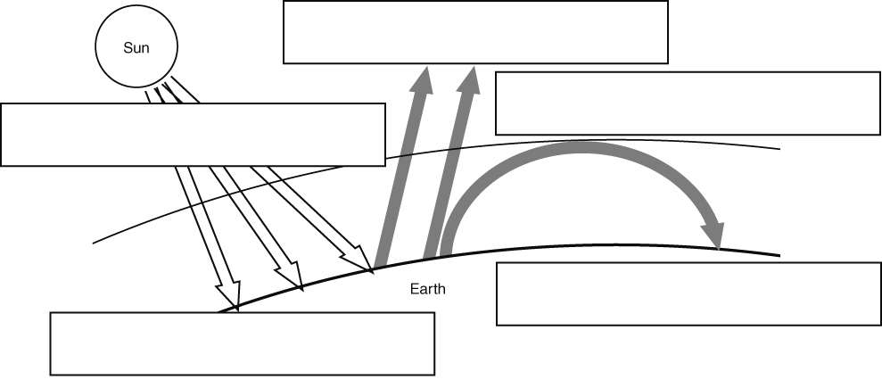
- Draw lines to link the sentence starters with their correct endings.
Natural causes of changes in the Earth’s temperature include … |  | carbon dioxide and other gases.
Global warming is caused by … |  | transport and electricity generation from power stations.
Greenhouse gases include … |  | the amount of energy transferred from the Sun to the Earth, and the tilt of the Earth’s axis.
Global emissions of carbon dioxide have increased over the past  200 years because … |  | an increase in the greenhouse effect because there are more greenhouse gases in the atmosphere.
The largest sources of carbon dioxide emissions are … |  | there has been an increase in the burning of fossil fuel.
I can…
- describe the greenhouse effect and how it is caused
- describe how human activity may be causing global warming.

Some reflected energy is transferred to space. | As the Earth’s surface gets warmer, it emits more energy.
Energy is transferred from the Sun to the Earth’s surface. | Some energy is absorbed by greenhouse gases and transferred back to the Earth’s surface.
Most energy is absorbed by the Earth’s surface, making it warmer.

