- Most vehicles burn hydrocarbon fuels to release energy for movement.
- Write a word equation to describe the complete combustion of a hydrocarbon fuel.
- Name all the products of the incomplete combustion of a hydrocarbon fuel.
- Explain why incomplete combustion happens in a car engine.
- Car engines are a source of several air pollutants.
- Sulfur dioxide is formed from sulfur impurities in the hydrocarbon fuel.
Write a word equation to show the formation of sulfur dioxide in a car engine.
- Nitrogen oxides are produced by the reaction of gases in the air at the temperature of the engine. Write a word equation to show the formation of nitrogen oxides in a car engine.
- Explain why incomplete combustion of fuel is even more harmful to the environment than complete combustion.
- Sulfur dioxide and nitrogen oxides are pollutants because they can result in acid rain.
- Describe as fully as you can how acid rain is produced.
- Explain why acid rain is harmful.
The pie charts show the sources of emissions of three air pollutants measured in the UK in 2012. Use these charts to help you answer Questions 4 and 5.
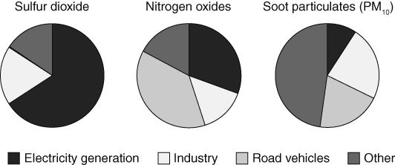
- For which of the pollutants are vehicles the greatest source? Explain how you worked out this answer from the pie charts.
- Since December 2007 only ultra low-sulfur petrol and diesel have been sold in UK petrol stations. Suggest how the road vehicles segment on the sulfur dioxide pie chart may have been different before 2007, and explain your answer.
- a What was the greatest source of sulfur dioxide in 2012?
b Use your answer to part a to suggest a method that would have the most impact in reducing sulfur dioxide concentrations in the air.
- All petrol cars made since 1992 have been fitted with a catalytic converter. Explain what effect this has on each of the pollutants produced by these vehicles.
- Suggest how pollution from road transport could be further reduced. Explain your answer.
I can…
- explain how fossil fuels produce pollutants when they are burnt.

