Name Class Date
- Circle the names of non-metal oxides in this list.
magnesium oxide sulfur dioxide carbon dioxide zinc oxide
- The non-metal oxides in Question 1 are pollutants. What is a pollutant?

- Name one source of these pollutants.

- The graph shows the amount of sulfur dioxide gas released into the air in the UK each year between 1970 and 2012.
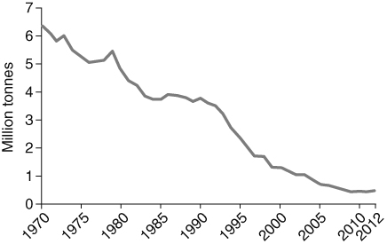
- Complete the word equation to show how sulfur dioxide is formed.
+ → sulfur dioxide
- Sulfur dioxide can cause acid rain. Why is acid rain a problem?

- Use the graph to help you describe why acid rain is much less of a problem in the UK now compared with 30 years ago.

- Carbon monoxide and soot particles are formed when there is incomplete combustion in a
car engine.
- What does incomplete combustion mean?

- Why is carbon monoxide a pollutant?

- Why is soot a pollutant?

I can…
- recall examples of pollution caused by burning fossil fuels
- interpret information about sulfur dioxide pollution.

