

The cards show the different stages in the formation of acid rain and some of its effects.
- Cut out the cards and arrange them on a piece of paper to form a flow chart. The shape of your flow chart should be something like this:
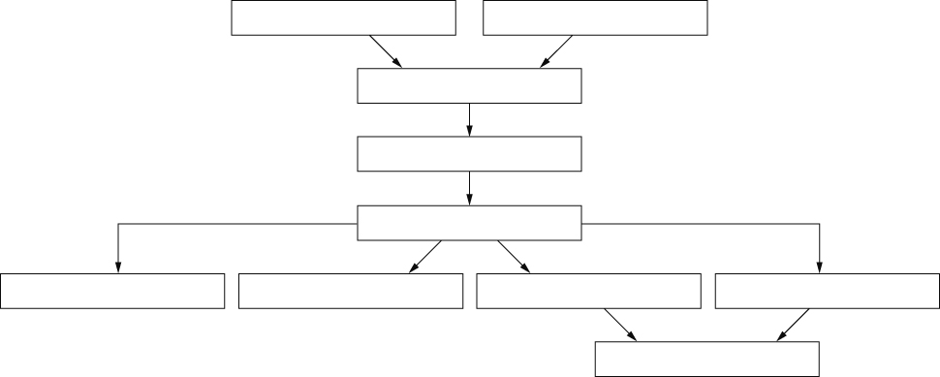
- Show your flow chart to your teacher and then stick the cards down.
- Draw lines to join the cards.
I can…
- identify causes and effects of acid rain.

A  Fish die in acidic lakes. | B  Acidic gases dissolve in moisture in the air.
C  Acid rain reacts with chemicals in the soil to release poisonous compounds. | D  Nitrogen oxides are produced by car engines.
E  The dissolved gases make rain more acidic. | F  Acid rain falls onto the land and runs into lakes and rivers.
G  Plants become unhealthy. | H  Acid rain speeds up the weathering (breaking down) of rocks.
I  Burning fossil fuels, such as petrol and diesel, produces carbon dioxide, sulfur dioxide and nitrogen oxides. | J  Acid rain washes some mineral salts out of the soil.

