Name Class Date
- Below are two hazard symbols that are particularly important in fires. Identify what each symbol means, and why any substance with this symbol is dangerous in a fire.
A  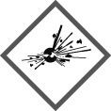 | This means  This is dangerous because
B  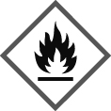 | This means  This is dangerous because
- The table below describes four different fires. For each fire, complete the last two columns in the table. If you put ‘fire extinguisher’ in the second column, you must also say which type you plan to use: water, powder, foam or carbon dioxide gas.
Type of fire | How to put out the fire | What is removed: heat/ fuel/oxygen? (it may be more than one of these)
chip pan fire
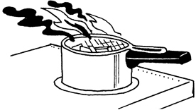
plane fuel fire
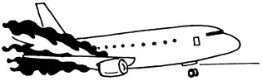
electrical fire
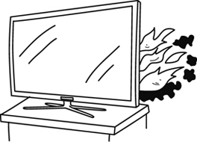
forest fire
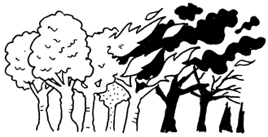
I can…
- use the fire triangle to explain how to control a fire
- identify hazard symbols for substances likely to cause fires.

