Your teacher may watch to see if you can:
- follow instructions to safely carry out an investigation.
Aim  To plan and carry out an investigation to show which fuel releases the most energy during combustion.  Introduction  There are many kinds of fuel that can be burnt to release energy for heating. These include solid fuels such as coal, liquid fuels such as petrol and ethanol, and gas fuels such as hydrogen and methane. Some fuels release more energy than others during combustion.  You will plan an investigation to find out which of four liquid fuels releases the most energy, using the apparatus shown. The fuel in the burner combusts in air to release energy that heats the water in the beaker. | 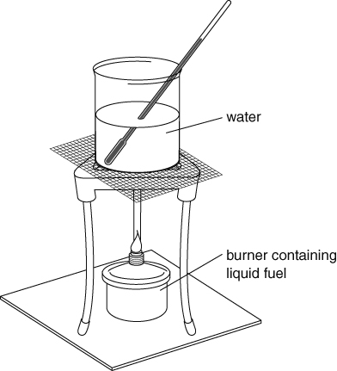
Method
Apparatus  - 4 spirit burners containing fuels A–D  - balance ● beaker ● stopclock  - tripod ● gauze ● heat-resistant mat  - thermometer ● water ● wax taper |  Wear eye protection. Tie hair back and keep the heating area clear. Spirit burners must be kept upright. All fuels are highly flammable.
Planning
- In this investigation, what is the independent variable and what is the dependent variable?
- Explain how the dependent variable is related to the energy released during combustion of
the fuel.
- Other variables in the experiment include:
- mass of water iv time that fuel is allowed to burn
- volume of beaker v height of beaker above flame.
- mass of fuel
For each variable, consider:
- how it might affect the results
- whether it needs to be controlled
- how it could be controlled.
- Suggest any other variables that might affect the results, and how they should be controlled.
- Use the answers to the questions above to help you plan your investigation. Show your plan to your teacher before you start your investigation.
- Record your results in a table and use them to draw a chart.
- Draw a conclusion from your results.
- Evaluate your results and suggest how the experiment could be improved to give better results.
I can…
- plan and carry out an experiment to compare the energy released by burning fuels.

