Your teacher may watch to see if you can:
- follow instructions to carry out a fair test.
Aim
To investigate the effect of candle flame height (inside a container) on the length of time it takes to go out.
Introduction
Candles are made from a hydrocarbon wax. There are many variables that could affect the time it takes the candle flame to go out. To carry out a fair test, where only the height of the candle affects the time, all other variables must be controlled.
- Look at the apparatus in the box.
- Which variables, apart from the height of the block on which the candle stands, could vary in a way that affects the time that the candle flame burns for?
- What could be done to control these variables, so that they don’t affect the time?
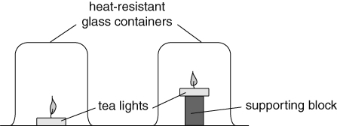
Method
Apparatus  - 2 tea lights ● 2 heat-resistant glass containers  - stopwatch ● ruler  - wax taper ● 2 heat-resistant mats  - modelling clay ● small block |  Open flames can cause fires. Tie long hair back and keep loose clothing away from flames. Allow the glass containers to cool before touching them.
A If the glass containers have a pouring lip, block the lip with a small piece of modelling clay to prevent air from entering when the containers are placed top-down on the bench.
B Place one tea light on a heat-resistant mat. Place the other tea light on the block on a
heat-resistant mat.
C Measure the height of the base of the wick of both lights from the mat and record the values.
D Use a lit wax taper to light both lights. Cover both lights at the same time with the glass containers and start the stopwatch.
E Measure the time taken for each flame to go out and record the values.
Considering your results/Conclusions
- What do your results show about the effect of height of candle on the time taken for the flame to go out?
- Suggest a reason why height had this effect.
Evaluation
- Explain why you can be sure that this effect was caused by the height of the flame and not something else.
I can…
- identify variables in an experiment that need to be controlled and how to control them.

