Some alcohols can be used as fuels, like hydrocarbons. For example, bioethanol is used instead of petrol in some vehicles.  Students carried out an experiment to compare the amount of energy released by a range of alcohols. The diagram shows the equipment used in the experiment.  In the experiment, the mass of fuel was measured before combustion. Combustion continued until 100 cm³ of water increased in temperature by 30 °C, when the flame was put out. The mass of fuel left at the end of the experiment was also measured. The table shows the results. |  | 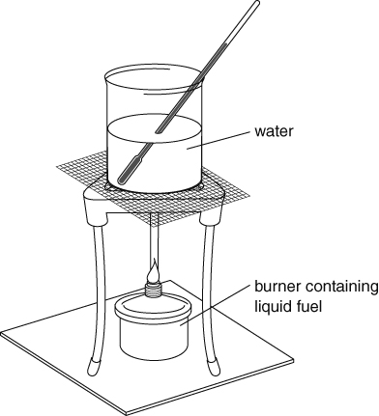
Alcohol | Initial mass of fuel (g) |  | Final mass of fuel (g)
methanol | 256.36 |  | 255.88
ethanol | 168.05 |  | 167.64
propanol | 251.34 |  | 250.95
butanol | 216.35 |  | 216.08
pentanol | 120.46 |  | 120.20
hexanol | 275.62 |  | 275.37
- Combustion reactions are exothermic.
- Explain what exothermic means.
- Explain the importance of this for controlling fires.
- Look at the equipment for the experiment.
- Describe what happens during the experiment.
- Describe one weakness of the experimental set-up for this experiment.
- Explain the importance of your answer to part b for the reliability of the results.
- Suggest variables that would need controlling during the experiment, and how they could be controlled.
- Using the data in the table, calculate the mass of each fuel used.
- Use your answers to Question 4 to identify the fuel that releases the most energy per gram of fuel. Explain your answer.
- The table below shows the price per litre of each of the alcohols.
Alcohol | methanol | ethanol | propanol | butanol | pentanol | hexanol
Price per kg (£) | 0.43 | 0.71 | 0.86 | 0.83 | 6.30 | 2.46
- Use this information and your answer to Question 5 to suggest which alcohol would make the cheapest and most useful fuel.
- Suggest what else you might need to know so that you could decide which was the best fuel to use in a vehicle.
I can…
- evaluate data on burning fuels.

