
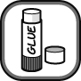
Name Class Date
Cut out each of the boxes and stick them in the correct places on the fire triangle.
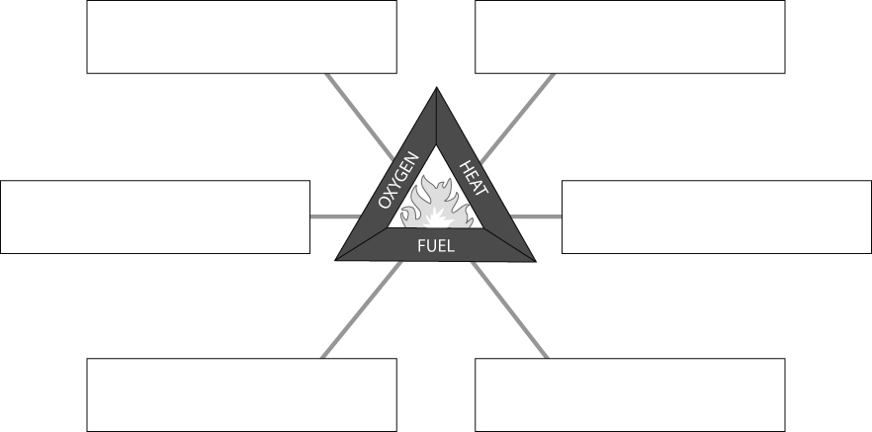
I can…
- use the fire triangle to explain how to control a fire.

the gas in the air that is needed for things to burn | a substance that contains a store of energy | energy needed to start a fire
a water extinguisher cools the fire and takes this away | taken away if you smother a fire with a fire blanket | cutting down trees in a forest fire takes this away

