Name Class Date
- The diagram shows magnesium ribbon that has been heated strongly in air. What evidence in this diagram shows that a reaction is happening? Tick (✓) the correct box.
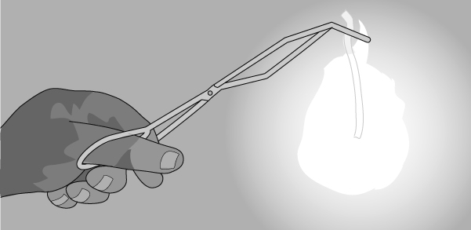
- The magnesium is changing colour.
- The very bright flame shows that energy is released.
- The magnesium gets hotter.
- What kind of reaction is shown happening in the diagram? Circle the correct answer.
neutralisation oxidation revision
- Which gas in air does the magnesium react with? Tick (✓) one box.
- carbon dioxide
- nitrogen
- oxygen
- Write a word equation to model what happens in the reaction shown above.
+ →
- When copper metal reacts with oxygen, copper oxide is formed. Write a word equation for this reaction.

- If the mass of copper and the mass of oxygen were measured before the reaction, what would be the mass of copper oxide formed? Tick (✓) one box.
- The same as the mass of copper added to the mass of oxygen.
- More than the mass of copper added to the mass of oxygen.
- Less than the mass of copper added to the mass of oxygen.
I can…
- describe oxidation reactions of metals
- state what happens to mass in a chemical reaction.

