Your teacher may watch to see if you can:
- follow instructions carefully
- work safely.
Aim
To measure the change in mass when magnesium is burnt in air.
Introduction
When magnesium burns in air, it reacts with oxygen to form magnesium oxide.
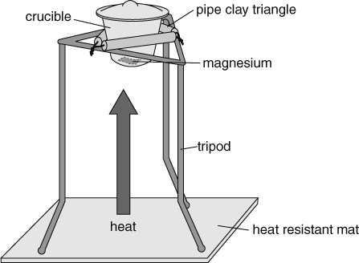
Method
Apparatus  - magnesium ribbon ● tongs  - pipe clay triangle ● crucible with lid  - Bunsen burner ● tripod  - access to balance ● emery paper  - heat-resistant mat |  Eye protection should be worn. Use tongs to handle apparatus, as it will take time to cool down after heating. Do not look directly at burning magnesium.
A If the magnesium looks dull or black, rub it with emery paper until it is shiny.
B Measure the mass of the crucible and lid to two decimal places. Record the mass in the table on the next page.
C Twist the magnesium ribbon into a loose coil and place it in the crucible. Measure the mass of the crucible, lid and magnesium accurately. Record the mass.
D Set up the apparatus as shown in the diagram. Make sure that the crucible is held securely and that the lid is fully on.
E Light the Bunsen burner and, using a roaring flame, heat the crucible.
F Once the magnesium starts to burn, use the tongs to slightly lift the lid to let in air. Don’t allow the flame from the magnesium to escape, as this may allow some magnesium oxide to escape.
G Keep heating and lifting the lid until there is no further reaction. Use the tongs to remove the crucible lid and place it on the heat-resistant mat. Continue heating for another two minutes.
H Turn the Bunsen burner off and allow everything to cool.
I Measure the mass of the crucible, lid and product.
Name Class Date
Results table
- Complete this table of results.
 |  | Mass (g)
mass 1 | crucible + lid
mass 2 | magnesium + crucible + lid
mass 3 | product + crucible + lid
Considering your results/Conclusions
- Calculate the mass of magnesium by subtracting mass 1 from mass 2.
mass of magnesium = – = g
- Calculate the mass of magnesium oxide by subtracting mass 1 from mass 3.
mass of magnesium oxide = – = g
- Describe the difference in mass between the magnesium and the magnesium oxide.

- Explain the difference in mass between the magnesium and the magnesium oxide.

- Calculate the mass of oxygen that reacted with the magnesium. Show your working in the space below.
- Describe how the experiment could be improved to get more accurate results. Explain your answer.

I can…
- state what happens to mass in a chemical reaction
- explain the change in mass seen in reactions.

