- A magnesium flare is a bright light produced when magnesium metal burns in air. It has several military uses. Magnesium flares may be dropped at night to illuminate a landing area for paratroopers. They may also be launched from planes or helicopters as decoys, to attract
heat-seeking missiles that usually target hot engines.
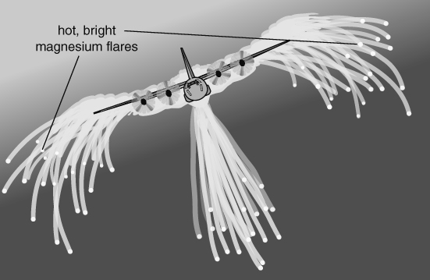
- Which gas in air does the magnesium in the flare react with?
- What kind of reaction is happening when magnesium reacts with this gas?
- What is the evidence that the magnesium is reacting? Explain your answer.
- Write word equations for the reaction of each of these metals with the gas.
magnesium
lead
potassium
- When zinc powder is heated strongly in air a white ash is formed.
- What is the white ash?
- How does the mass of the ash compare with the mass of the zinc powder before the reaction?
- Explain your answer to part b.
- The table shows the mass of a spirit burner and the hydrocarbon fuel it contains during a  20-minute period after the burner was lit. |  |  |  | 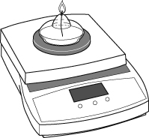
 | Time (min) | 0 | 5 |  | 10 | 15 | 20
 | Mass of burner + fuel | 182.3 | 181.8 |  | 181.2 | 180.7 | 180.2
- Describe what the results show.
- Explain why the results show this pattern.
I can…
- identify the changes that occur when metals are heated strongly
- explain changes in mass seen in oxidation reactions.

