Scientists used the phlogiston theory to explain some of their observations. Now that we no longer believe that phlogiston exists we must be able to explain the observations in a different way.
- Explain each idea in the boxes in modern terms. If you can, give the modern names for the substances mentioned. Try to write word equations to help your explanations. The first one has been done for you. (Hint: a ‘calx’ is usually an oxide. Some oxides decompose when you heat them.)
- Write a symbol equation for the reaction in box 1.
- Use the information in the boxes to evaluate the phlogiston theory. Identify its good points (where it can explain the observation) and its weak points.
- Write a sentence to explain why scientists no longer believe the theory.
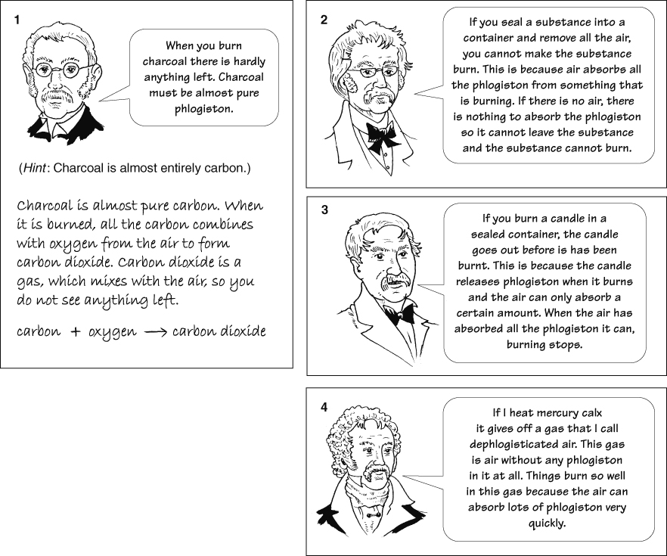
I can…
- explain and compare the oxygen and phlogiston theories for combustion and oxidation.

