Name Class Date
- Hydrogen and oxygen react to form water.
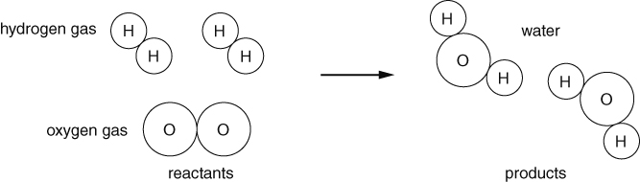
- Colour the oxygen atoms in red. Colour the hydrogen atoms in grey.
- How many hydrogen atoms are there in all the reactants?
- How many hydrogen atoms are there in all the products?
- How many oxygen atoms are there in all the reactants?
- How many oxygen atoms are there in all the products?
- If the masses of oxygen and hydrogen were measured before the reaction, and the mass
of water formed was measured after the reaction, what would we see?
Tick (✓) the correct box.
- total mass of hydrogen and oxygen greater than mass of water
- total mass of hydrogen and oxygen same as mass of water
- total mass of hydrogen and oxygen less than mass of water
- When a metal reacts with oxygen, the metal oxide is formed. Write down the products of these reactions.
- magnesium + oxygen →
- copper + oxygen →
- What is the name of this kind of reaction?
- Sometimes it seems as if mass has been gained in a reaction.
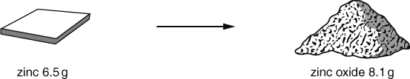
The zinc has combined with oxygen to form zinc oxide.
Where did the oxygen come from?
I can…
- state what happens to mass in an oxidation reaction
- describe oxidation reactions of metals.

