Most car engines have an internal combustion engine that contains four pistons, each in a separate cylinder. At the top of each chamber are two valves. One valve lets substances into the cylinder and the other lets exhaust gases out. The pistons are connected together by a rotating crankshaft, which also transfers movement to the wheels.  The four pistons go through the same four ʻstrokesʼ of the cycle, but at different times.  - 1st stroke/intake: The piston is pulled down as the crankshaft turns. This creates a vacuum in the cylinder, which draws a fuel/air mixture in through the inlet valve. | 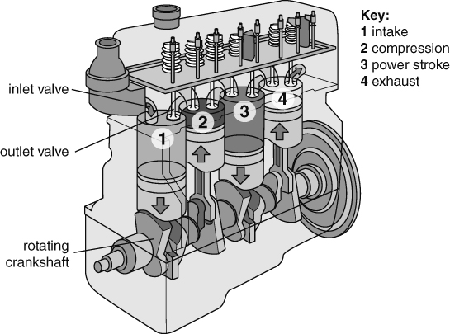
- 2nd stroke/compression: The piston is pushed up again by the rotating crankshaft. This compresses (squashes) the fuel/air mixture at the top of the cylinder, as both valves are closed.
- 3rd stroke/power: A spark at the top of the cylinder ignites the fuel/air mixture. The very hot gases produced expand rapidly, pushing the piston to the bottom of the cylinder. The linear movement of the piston is converted to circular movement by the shape of the crankshaft.
- 4th stroke/exhaust: The piston is pushed back up the cylinder by the crankshaft, and the gases are pushed out of the outlet valve. This sets the piston in the right position to start the cycle again.
Use the information above and your own knowledge to answer these questions.
- a A steam engine is an external combustion engine. Explain why a car engine is called an ʻinternal combustionʼ engine.
b Briefly compare this kind of engine with how a steam engine works.
- Suggest why modern cars have this kind of engine and not steam engines. Give as many reasons as you can.
- Explain how a force is generated in the power stroke.
- The movement of the crankshaft also drives a fan that blows air across the engine. Suggest why the fan is needed.
- There are many reasons why an internal combustion engine may not work properly. For each of the following reasons, explain why the engine will not be effective.
- The car has run out of fuel.
- The spark fails or is weak.
- There is water in the fuel.
- The sealing rings around the pistons or valves are broken and let air into the cylinder.
Space rockets use a different kind of internal combustion engine, as shown on the right.  (Note: an oxidising agent releases oxygen.)  - Explain why the space rocket engine differs from a car engine. Suggest as many reasons as you can for the differences. | 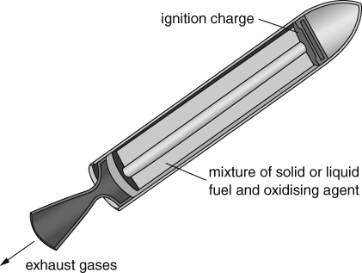
I can…
- use knowledge of combustion to explain how combustion engines work.

