Name Class Date
- Use one word from the box below to complete each of these sentences. (Note: some of the words will not be used.)
- Another name for burning is .
- Fuels formed by living organisms that died millions of years ago are called
fuels.
- A substance that contains only hydrogen and carbon is called a .
combustion explosion fossil hydrocarbon hydrogen
- This word equation models the combustion reaction between hydrogen and oxygen.
hydrogen + oxygen → water
- Is oxygen a reactant or product of this reaction? .
- Is water a reactant or product of this reaction? .
- Complete this word equation to model the combustion reaction of carbon and oxygen:
carbon + oxygen → .
- The diagram shows equipment used to test what is produced when the fuel in a spirit lamp
is burnt.
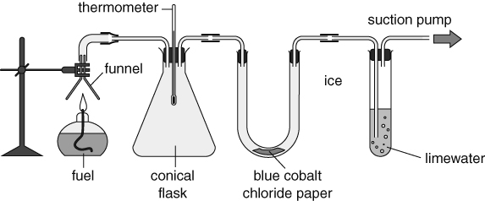
- What does the cobalt chloride paper test for? .
- What does the limewater test for? .
- How will the thermometer reading change during the experiment?

- Explain why the thermometer reading changes in this way.

I can…
- identify reactants and products in combustion reactions
- describe how the products of combustion reactions can be tested for.

