Name Class Date
Your teacher will set up this apparatus and light the spirit lamp, which contains a hydrocarbon fuel. (Note: it is the fuel that is burning, not the wick.)
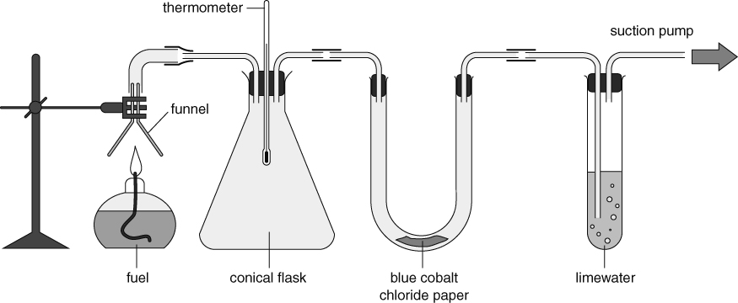
Use your observations of what happens to answer the questions below.
- Why is the suction pump needed?

- What happens to the temperature measured on the thermometer?

- What happens to the blue cobalt chloride paper and why does this happen?

- What happens to the limewater and why does this happen?

- Use your answers to Questions 3 and 4 to write a word equation for the combustion of the fuel.

- Which two observations are evidence that the combustion of fuel releases energy?
Explain your answer.

I can…
- identify the products from the combustion of a hydrocarbon
- use word equations to model the combustion of a fuel.

