Name Class Date
The data below describes how the temperature varies with time as a metal, and an alloy of the metal, are heated continuously until both have completely melted.
Time (minutes) | 0 | 2 | 4 | 6 | 8 | 10 | 12 | 14 | 16 | 18 | 20 | 22
Temperature of pure metal (°C) | 20 | 82 | 144 | 205 | 266 | 328 | 328 | 328 | 328 | 328 | 390 | 452
Temperature of alloy (°C) | 20 | 75 | 130 | 186 | 200 | 212 | 275 | 330 | 387 | 433 | 499 | 557
- Draw a line graph showing how the temperature changes as heating progresses for both the pure metal and the alloy. Use the same axes for both lines.
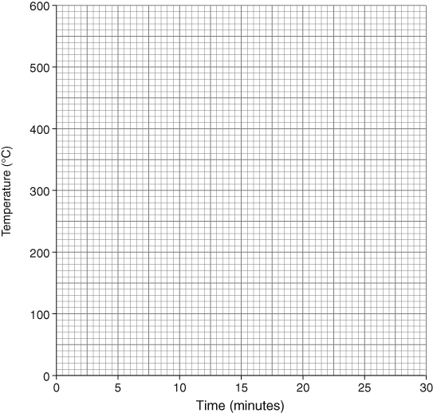
- What is the melting point of the pure metal? .
- What is the melting range of the alloy metal? .
- Describe two ways that the line graph for the alloy is different to the line graph for the pure metal.

- Why do we make alloys, and not just use the pure metals?

I can...
- plot and interpret temperature–time graphs for metals and alloys.

