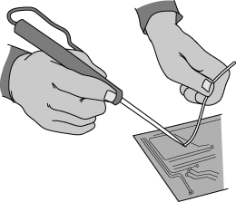 |   Solder, an alloy of lead and tin, is most commonly used to make joints in copper pipes and to connect electrical wires in circuits.  The alloy has a lower melting point than either lead or tin and flows well to make a secure joint. The properties of an alloy depend on the metals it contains and the nature of the mixture. Increasing the lead content makes the solder solidify more slowly, while increasing the tin content makes the alloy stronger.
The table below gives the melting points of different mixtures of lead and tin.
Melting point (°C) | 327 | 292 | 256 | 221 | 185 | 193 | 201 | 209 | 216 | 224 | 232
% lead | 100 | 90 | 80 | 70 | 60 | 50 | 40 | 30 | 20 | 10 | 0
% tin | 0 | 10 | 20 | 30 | 40 | 50 | 60 | 70 | 80 | 90 | 100
- What is an alloy?
- Why are alloys made?
- Describe two useful properties that solder should have.
- Explain why the solder used to join copper water pipes usually has a high tin content.
- Use the data in the table above to draw a graph showing how the melting point of the solder changes as the percentage of tin and lead changes.  The graph axes should look like the ones shown opposite. | 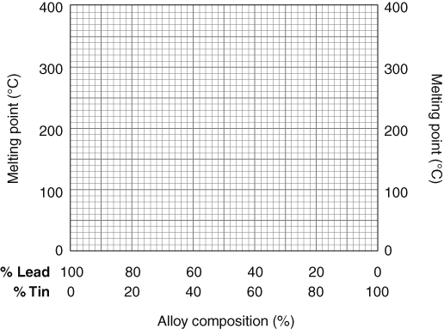
- Use the graph to answer the following questions.
- Which metal has the highest melting point?
- What mixture of tin and lead has the same melting point as pure tin?
- How does adding a small amount of another metal affect the melting point of a metal?
- Unlike pure metals, which have a sharp melting point, mixtures tend to melt over a range of temperatures. How could this be shown on the graph you drew for question 5?
I can...
- explain why metals are often alloyed with other elements
- plot and interpret graphs of melting point for mixtures of varying compositions.

