
Name Class Date

- Complete the following sentences about alloys.
- An alloy is a metal that has .
- Alloys will have different from those of the metal(s) they contain.
- Alloys have different because they have different .
- The melting points of an alloy will be than the melting point of the main metal.
- Examples of alloys include , and .
- Some alloys are harder than the pure metal(s) they contain so their shape cannot be changed easily.
Cut out the diagrams, labels and statements below and arrange them to explain why an alloy is harder than the pure metal.
Atoms are arranged in even layers and in straight lines. | Atoms layers are distorted by atoms of different size. | A force moves the layers of atoms over each other. | A force cannot move layers of atoms over each other.
pure metal | alloy | Layers can slide over each other easily. | Layers cannot slide over each other easily.
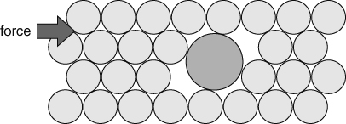 |  | 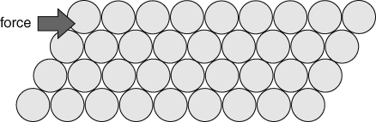
I can...
- explain what alloys are and why they are used
- use models to explain the properties of alloys.

