

- Cut out and rearrange these particle diagrams and statements to describe what is happening as a solid is heated and to explain the changes of state that occur.
A gas forms when the particles can move freely in all directions. |  | Heating a solid makes the particles move faster. |  |  | Heating a liquid makes the particles move about in all directions. |  |  | A liquid forms when the particles can move over each other.
MELTING   | SOLID |  |  | GAS |  | EVAPORATION   |  |  | LIQUID
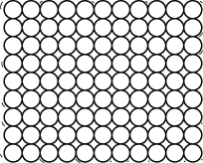 |  |  | 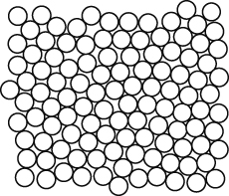 |  |  |  | 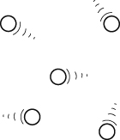

- a Cut out the labels, statements and diagrams of particles. Complete the statements and stick them with the correct diagrams and labels. | In a pure metal all the atoms are the | Alloy | Pure metal
 | An alloy contains  atoms mixed together. | 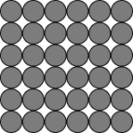 | 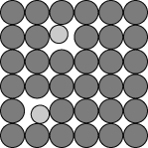
b Describe two ways that the melting point of an alloy is different from the melting points of pure metals.
I can...
- distinguish between pure substances and mixtures
- describe what happens during changes of state.

