Name Class Date
- Complete this diagram, which summarises changes of state, using words from the box below.
cooling evaporation heating melting solid
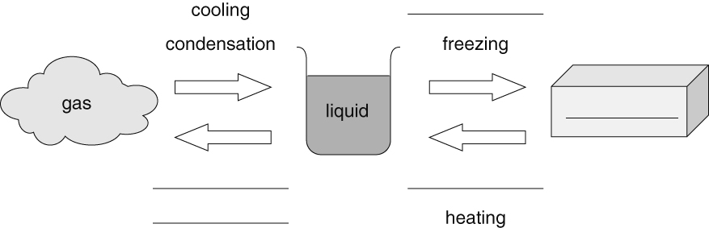
- Indicate whether the particle diagrams on the right represent pure substances or mixtures. |  | 

- Use the word list and table to complete these sentences about alloys.  corrosion harder lower  mixture metals stronger | The alloy brass contains copper and zinc.
  Substance | Corrosion resistance | Strength | Hardness
  brass | good | high | very high
  copper | good | medium | high
  zinc | poor | low | low
- An alloy is a of different .
- Brass is better to use for door locks and hinges than copper because it is
and it is .
- Brass will last longer than zinc outside because it resists .
- Adding small amounts of zinc to copper will its melting point.
I can...
- describe what happens during changes of state
- distinguish between pure substances and mixtures from particle diagrams
- state the meaning of an alloy and explain their usefulness.

