A Year 8 class set up the experiment shown to investigate the reactions of magnesium with two different acids.  20 cm³ of acid was placed in a test tube. A 1 cm piece of cleaned magnesium ribbon was added.  The time it took for the magnesium to completely disappear was measured. This procedure was repeated three times with each acid.  The class results are shown below. | 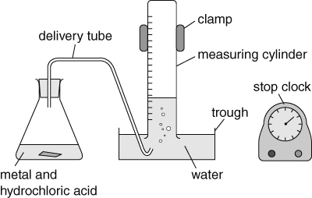

Group 1 | Sulfuric acid (s) | Nitric  acid (s) |  | Group 2 | Sulfuric acid (s) | Nitric  acid (s) |  | Group 3 | Sulfuric acid (s) | Nitric  acid (s)
1st try | 34 | 50 |  | 1st try | 37 | 52 |  | 1st try | 78 | 100
2nd try | 38 | 54 |  | 2nd try | 38 | 54 |  | 2nd try | 80 | 95
3rd try | 36 | 49 |  | 3rd try | 38 | 52 |  | 3rd try | 76 | 103
Group 4 | Sulfuric acid (s) | Nitric  acid (s) |  | Group 5 | Sulfuric acid (s) | Nitric  acid (s) |  | Group 6 | Sulfuric acid (s) | Nitric  acid (s)
1st try | 34 | 52 |  | 1st try | 17 | 50 |  | 1st try | 34 | 50
2nd try | 37 | 49 |  | 2nd try | 18 | 46 |  | 2nd try | 15 | 47
3rd try | 35 | 54 |  | 3rd try | 19 | 52 |  | 3rd try | 36 | 48
- From the results, which acid reacts faster with magnesium? Explain your choice.
- Name three variables that should have been kept the same to make the test fair.
- Suggest one reason why the repeated experiments didn’t always get the same result.
- Using group 1’s results, calculate the mean time for metal to disappear in each acid.
- The mean value for the time taken is likely to be more accurate than any individual result. What does ‘accurate’ mean when talking about experimental results?
- Explain why group 2’s results can be described as the most ‘repeatable’.
- Which of group 6’s results is anomalous? Explain your answer.
- Compare the results for groups 1 and 4. Do the results look reproducible? Explain your answer.
- One of the groups used a solution of sulfuric acid that was twice as concentrated as the acid used by the other groups. Identify which group used the more concentrated acid and explain your choice.
- One group didn’t read the instructions properly and used 2 cm pieces of magnesium instead of 1 cm pieces of magnesium. Identify the group that used the larger pieces of magnesium and explain your choice.
- Copy and complete the word equations for the two reactions used in the experiment.
- magnesium + sulfuric acid → + .
- magnesium + nitric acid → + .
I can...
- explain what is meant by the terms: accurate, reliable, repeatable and reproducible
- describe the reactions of different metals with acids in words and using word equations.

