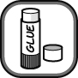

- Cut out the diagram and labels below and arrange them on a sheet of paper to summarise the reactions that some metals have with acids.
the salt is formed in the solution | 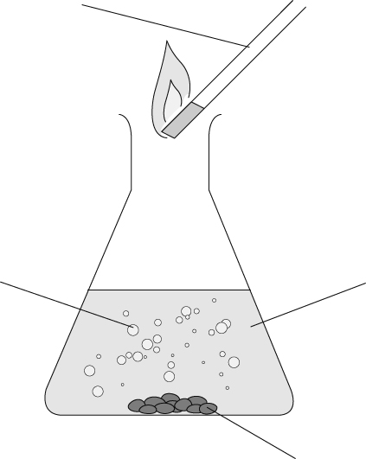 | Pop!
magnesium metal |  | hydrochloric acid
bubbles of hydrogen |  | test for hydrogen
- When metals react with acids they form a salt and hydrogen. The type of salt formed depends on the metal and acid used.
Cut out the words and symbols below. Arrange them to make as many different word equations that represent the reactions of metals and acids as you can.
hydrochloric acid | hydrochloric acid | sulfuric acid | hydrogen | hydrogen | ✦ |  | 
sulfuric acid | nitric acid | nitric acid | hydrogen | hydrogen | ✦ |  | 
potassium | tin | zinc | hydrogen | hydrogen | ✦ |  | 
potassium | tin | zinc | chloride | chloride | ✦ |  | 
aluminium | magnesium | calcium | nitrate | nitrate | ✦ |  | 
aluminium | magnesium | calcium | sulfate | sulfate | ✦ |  | 
I can...
- describe the reactions of metals with acids
- write word equations for reactions of metals and acids.

