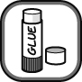

- Cut out the descriptions of the reactions below and arrange them in order of reactivity, with
the most reactive first. The reactivity of some pairs of metals may appear to be the same.
- Where a reaction occurs and the acid is named, write word equations to represent the
chemical change beside the description.

Aluminium  Once the surface has been cleaned off, aluminium reacts steadily with hydrochloric acid to produce some bubbles of hydrogen gas. |  | Magnesium  Magnesium has a fast reaction with hydrochloric acid, producing a strong stream of bubbles of hydrogen gas. | 
Calcium  Very fast reaction with hydrochloric acid, producing a lot of hydrogen gas quickly. | 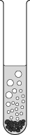 | Potassium  Potassium explodes in hydrochloric acid.  This reaction should not be attempted in the laboratory. | 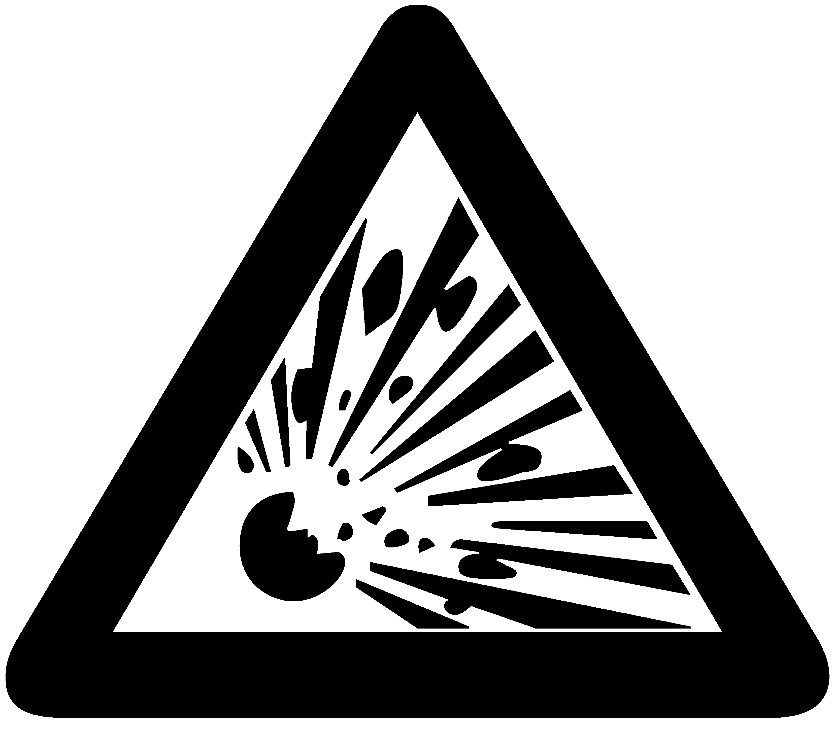
Copper  No visible reaction with dilute acids but reacts quite quickly with concentrated acids. |  | Silver  No reaction with any dilute acids but reacts slowly with some concentrated acids.
Gold  No reaction with dilute or concentrated acid. |  | Sodium  Violent reaction with hydrochloric acid and can explode under certain conditions.  This reaction should not be attempted in the laboratory.
Iron  Slow reaction with hydrochloric acid, producing a slow stream of hydrogen bubbles. | 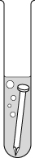 | Tin  Reacts very slowly with hydrochloric acid, producing a few bubbles of hydrogen gas. | 
I can...
- use information on the reactions of metals with acids to place them in an order of reactivity
- model simple reactions of metals and acids using word equations.

